### PROJECT NAME

Ecommerce Design and Development

A Project Report/Thesis has been submitted to the Department of Computer Science and Engineering, Hajee Mohammad Danesh Science and Technology University in partial fulfillment of the requirements for the degree of B.Sc. (Engineering) in Computer Science and Engineering.

### Submitted by

F M ZAHIDUL ISLAM

Student ID: 1702009

Session:2017

ABDULLAH AL ANUS

Student ID: 1702059

Session:2017

RIADUL ISLAM ROBIN

Student ID: 1702025

Session:2017

The project has been supervised by

Md. Nahid Sultan

Assistant Professor

Department of Computer Science and Engineering

in partial fulfillment of the requirements for the

degree of B.Sc.(Eng.) in Computer Science and Engineering

## ACKNOWLEDGEMENT

We would like to express our sincere thanks and gratitude to our Honourable supervisor MD. Nahid Sultan sir and our Honourable Co-supervisor MD. Abu Marjan sir for providing us the supervision with the possibility to complete this project with the right guidance and advice.

Furthermore, I would also like to acknowledge with much appreciation the crucial role of faculty members on this occasion.

Finally, I would like to thank my parents and friends who have helped me with their valuable suggestions and guidance and have been very helpful in various stages of project completion.

## 

## 

## CERTIFICATION

This is to certify that the work entitled “Ecommerce Design and Development” by F M Zahidul Islam, Abdullah Al Anus, and Riadul Islam Robin has been carried out under our supervision. To the best of our knowledge, this work is original and was not submitted anywhere for a diploma or a degree.

Co-supervisor

…………………..

(Md. Sohrawordi)

Assistant Professor

Department of Computer Science and Engineering

Hajee Mohammad Danesh Science and Technology University, Dinajpur-5200, Bangladesh

Supervisor

……………………

(Md. Nahid Sultan)

Assistant Professor

Department of Computer Science and Engineering

Hajee Mohammad Danesh Science and Technology University, Dinajpur-5200, Bangladesh

## DECLARATION

The work entitled “Ecommerce Design and Development” has been carried out in the Department of Computer Science and Engineering, Hajee Mohammad Danesh Science and Technology University is original and conforms to the regulations of this University.

We understand the University‟s policy on plagiarism and declare that no part of this report has been copied from other sources or been previously submitted elsewhere for the award of any degree or diploma.

| ………………………………  F M ZAHIDUL ISLAM  Student ID: 1702009  Session:2017 | ……………………………  ABDULLAH AL ANUS  Student ID: 1702059  Session:2017 | ………………………………  RIADUL ISLAM ROBIN  Student ID: 1702024  Session:2017 |
| --- | --- | --- |

## ABSTRACT

E-commerce is fast gaining ground as an accepted and used business paradigm. More and more business houses are implementing websites providing functionality for performing commercial transactions over the web. It is reasonable to say that the process of shopping on the web is becoming commonplace.

Our aim is to develop a user-friendly UI for e-commerce design, development, and management. The system provides all the functionalities to make a successful connection via Business and consumer. We have faced so many challenges to develop the system. Now all of the hard work came true when we completed the development of the system.

around 8,000 e-commerce pages are using social media to reach their product to the customers right now in 2022. We can make e-commerce to connect the seller and buyer through the project. Still, Bangladesh needs more e-Commerce sites to sell and buy their products. The Project has focused on developing a B2C Website that can connect a business to their seller to sell anything to the customer online.

Once a customer entered his own username and password, at that time automatically one shopping cart will be created, once the user selects an item it will add to the cart. In case the user thinks the selected item is not useful for me, then deleted that item from the shopping cart.

The customer selected some items, but in his credit or debit card haven’t that much balance, then he was logout from the website, the selected items are stored at the cart with specific users with his allotted carts, after some days he bought those items then automatically deleted from the cart.

## 

## Table of Contents

| Chapter 1: Introduction | | 08 |
| --- | --- | --- |
|  | 1.1 Overview | 08 |
| 1.2 Objective | 08 |
| 1.3 Goal | 09 |
| Chapter 2: Ecommerce Technologies | | 10 |
|  | 2.1 Ecommerce Business Type | 10 |
| 2.2 Front End Technology | 11 |
| 2.3 BackEnd Technology | 13 |
| Chapter 3: System Analysis & Specification | | 15 |
|  | 3.1 System Analysis | 15 |
| 3.2 System specification | 16 |
| Chapter 4: System Design | | 17 |
|  | 4.1 Introduction to design | 17 |
|  | 4.2 UML Diagrams | 18 |
|  | 4.3 Data flow diagram | 25 |
| Chapter 5: Database Design | | 29 |
|  | 5.1 ER Diagram | 29 |
|  | 5.2 MySQL Data Table | 31 |
| Chapter 6: Implementation and Experiment result | | 35 |
|  | 6.1 Modules and Functionalities | 35 |
|  | 6.2 Testing | 37 |
|  | 6.3 System Output Screen | 39 |
| Chapter 7: Conclusion and Future work | | 49 |
|  | 7.1 Conclusion | 49 |
|  | 7.2 Future enhancement | 50 |
| Chapter 8: Reference amd Bibilography | | 51 |
|  | 8.1. Bibliography | 51 |
|  | 8.2 Reference | 52 |

## List of Figure

| 01 | Use case Diagram -admin | 19 |
| --- | --- | --- |
| 02 | Use case diagram - User | 20 |
| 03 | Activity Diagram: User side | 21 |
| 04 | Activity Diagram: Admin side | 22 |
| 05 | COLLABORATION DIAGRAM | 23 |
| 06 | Class Diagram for E-Commerce | 24 |
| 07 | Zero Level DFD | 25 |
| 08 | first Level DFD | 26 |
| 09 | Second level DFD for Admin | 27 |
| 10 | Second level DFD for user | 28 |
| 11 | Entity Relationship Diagram | 30 |

### 

### Chapter 1

## Introduction

The 21st century World is providing internet to everywhere of the world. The Business nature is completely changed due to the advantages of the internet. The ‘Online E-commerce System’ strives to provide solutions to develop and transfer easy and efficient ways in the digital age and to help reduces human pressure and time. In the Applied thesis. We conduct applied research on “Ecommerce Design and Development” which aims to build a web application written for all operating systems, designed to help users maintain and organize shop virtually. The main aim to conduct the project is to make the usage of this kind of software easier to use for both beginners and advanced users. It features a familiar and well-thought-out, attractive user interface, combined with strong searching Insertion and reporting capabilities. The report generation facility of the shop system helps to get a good idea of which are the various items brought by the members, making users possible to get the product easily. The ‘Online E-commerce Web application’ Services department strives to provide solutions to develop and transfer easy and efficient ways in the digital age and to help reduces human pressure and time. an online eCommerce System for a local seller to sell their product easily to visitors on the internet. The type of eCommerce system is a Business-to-Consumer (B2C) in nature. Ecommerce provides all the features of searching, buying, and making payments for the selected products.

### 1.1. Overview

Before Taking the Project to fulfill our graduation degree. We made deep research about the Project. According to our research, we found some information. The eCommerce Association of Bangladesh (e-Cab), the trade body for eCommerce in Bangladesh, estimates there are 700 eCommerce sites and around 8,000 eCommerce pages on Facebook. Facebook remains a popular method for advertising and selling products, to a point that many businesses badly need to create personal e-commerce websites.

As we see that around 8,000 e-commerce pages are using social media to reach their product to the customers right now in 2022. We can make e-commerce to connect the seller and buyer through the project. Still, Bangladesh needs more e-Commerce sites to sell and buy their products. The Project has focused on developing a B2C Website that can connect a business to their seller to sell anything to the customer online.

### 1.2. Objectives

E-commerce is fast gaining ground as an accepted and used business paradigm. More and more business houses are implementing websites providing functionality for performing commercial transactions over the web. It is reasonable to say that the process of shopping on the web is becoming commonplace. The objective of this project is to develop a general-purpose e-commerce store where any product (such as books, CDs, computers, mobile phones, electronic items, and home appliances) can be bought from the comfort of home through the Internet. However, for implementation purposes, this paper will deal with an online e-commerce store. An online store is a virtual store on the Internet where customers can browse the catalog and select products of interest. The selected items may be collected in a shopping cart. At checkout time, the items in the shopping cart will be presented as an order. At that time, more information will be needed to complete the transaction. Usually, the customer will be asked to fill or select a billing address, a shipping address, a shipping option, and payment information such as a credit card number. An email notification is sent to the customer as soon as the order is placed. So the objectives are quite clear we aim for developed an e-commerce Store where the system provides an easy way of surfing the e-commerce using an easy user interface with payment gateway and support systems.

### 1.3. Goal

The Goal is to Solve the Problems about selling and buying a product online. Where sometimes users couldn’t understand the functionalities of e-commerce and sometimes the admin couldn’t understand to handle an order. Which makes the service bad. We aim to solve the problem by developing e-commerce with an easy user interface for both consumers and admin.

The System also aims to develop so many functionalities that can solve real-life problems of E-commerce systems through digital technology. The project aims to develop e-commerce by which a seller or consumer or a store owner can sell his product nationwide. Users can buy any product online.

### Chapter 2:

## Ecommerce Technologies

In this chapter, We will discuss the technologies now we have to develop an e-commerce System. The Technology of the 21st century is quite advanced to develop e-commerce easily by some software and tools. We also discuss the types of e-commerce that the whole world is now using. The aim of the Thesis report is to explain all the technologies and properties of the e-commerce system. We will discuss the 4 types of e-commerce systems. If you’re starting an e-commerce business, odds are you’ll fall into at least one of these four general categories. Each has its benefits and challenges, and many companies operate in several of these categories simultaneously. Knowing what bucket your big idea fits in will help you think creatively about what your opportunities and threats might be.

## 2.1. E-commerce Business Type

There are four traditional types of e-commerce business models that exist in the world. If you’re starting an e-commerce business, odds are you’ll fall into at least one of these four general categories.

### B2C – Business to consumer.

B2C businesses sell to their end-user. The B2C model is the most common business model, so there are many unique approaches under this umbrella. Anything you buy in an online store as a consumer thinks wardrobe, household supplies, entertainment is done as part of a B2C transaction. The decision-making process for a B2C purchase is much shorter than a business-to-business (B2B) purchase, especially for items that have a lower value. Because of this shorter sales cycle, B2C businesses typically spend less marketing dollars to make a sale but also have a lower average order value and fewer recurring orders than their B2B counterparts.B2C innovators have leveraged technology like mobile apps, native advertising, and remarketing to market directly to their customers and make their lives easier in the process. The model allows consumers to easily connect with local lawn mowing services, garden and patio specialists, or snow removal experts.

### B2B – Business to business.

In a B2B business model, a business sells its product or service to another business. Sometimes the buyer is the end-user, but often the buyer resells to the consumer.B2B transactions generally have a longer sales cycle, but higher-order value and more recurring purchases. Recent B2B innovators have made a place for themselves by replacing catalogs and order sheets with e-commerce storefronts and improved targeting in niche markets. in 2020, close to half of B2B buyers are millennials nearly double the amount from 2012. As younger generations enter the age of making business transactions, B2B selling in the online space is becoming more important.

### C2B – Consumer to business.

C2B businesses allow individuals to sell goods and services to companies. In this e-commerce model, a site might allow customers to post the work they want to be completed and have businesses bid for the opportunity. Affiliate marketing services would also be considered C2B. Elance (now Upwork) was an early innovator in this model by helping businesses hire freelancers. The C2B e-commerce model’s competitive edge is in pricing for goods and services. This approach gives consumers the power to name their prices or have businesses directly compete to meet their needs. Recent innovators have creatively used this model to connect companies to social media influencers to market their products.

### C2C – Consumer to consumer.

A C2C business also called an online marketplace connects consumers to exchange goods and services and typically makes their money by charging transaction or listing fees. Online businesses like Craigslist and eBay pioneered this model in the early days of the internet.C2C businesses benefit from self-propelled growth by motivated buyers and sellers, but face a key challenge in quality control and technology maintenance. Bikroy.com can be a great example of the C2C Business system.

Our aim is to create a B2C e-commerce System. So We will Explain the existing technologies We will explain all the technologies that still exist now.

### 2.2. Front End Technology for e-commerce

Frontend is what appears on the user’s side most and what entices the users to give the website a stroll. Hence, the designers work at the base level of this process. The aim to choose the most creative and useful technologies to make the website look great, to build the website to load faster, to increase responsiveness and device portability.

Starting from a client-side scripting language to design tools everything is collaborated as one big team to develop the best website for your online business. Whereas, front-end scripting languages are the most essential subset of programming languages that perform specific functions within larger object-oriented back-end programming languages such as javascript.

With the advent of HTML5, Canvas, web application developers now have smart scripting languages, particularly AJAX and Action-script, incorporated into most of all modern browsers like Chrome, Firefox, IE10, and more. Dependability on plugins is less nowadays. However, below is a summary of some of the most used Front-end Technologies in which we have to expertise in such front-end technology.

#### HTML

HTML is probably the primary language of all the developer’s expertise at the very beginning. The reason is, HTML provides building blocks to all websites, particularly text and images.

#### JavaScript

Once there is a clear understanding of HTML and the webpage skeleton, there comes the need of enriching the page with more and more content. This is the trickiest part to building a better website for e-commerce business, as we all know content is what the customers look for in the website. Hence, JS is capable of a rich user experience for browser-based applications. An expert, skilled and trend-setting JS developer is a must for an e-commerce website development team.

#### ReactJS

Built and utilized by Facebook, React JS is a fast and flexible JavaScript library that enables front-end developers to build dynamic user experiences efficiently. All these JS libraries, frameworks are to create smart and faster loading of the content leveraging JS on the webpage to provide a seamless user experience. And, e-commerce website development companies hire the bests of the best in the relevant field to make their service, product, and solutions leave a unique user experience.

#### Ajax

Interesting thing is, Ajax is a developers’ dream; especially for front-end architects The reason probably is that Ajax allows the asynchronous update of the webpage content without reloading the whole page. Henceforth, Ajax gives actions within applications better responsiveness. Ajax is best for action-based services. For e-commerce, allowing the actions like filtering the right product, taking customer information, updating the purchase choice, survey run, and review processing, Ajax is more reliable to the developers.

#### JQuery

JQuery is a fast, small, and feature-rich JavaScript library. it makes things like HTML document traversal and manipulation, event handling, animation, and AJAX much simpler.

#### Responsive Web Design

Responsive web design is nothing but the web design approach aimed at crafting sites to provide an optimal viewing experience including easy reading and navigation with a minimum of resizing.

#### Bootstrap

Bootstrap is the most favorable to the developers and users at the same time. Since it is a sleek, intuitive, and powerful front-end framework for faster and easier web development to offer a seamless customer experience.

### 2.3. BackEnd Technology for E-commerce

Technologies are pretty complex and boring in the back-end. But, the developers know what can make the process more interesting. That is to use the right technology to do the right functionality work well.Let’s talk back-end, the skeleton behind the beautiful and enticing website we have been building the e-commerce system.

#### PHP

Among all other scripting languages, PHP is probably the most popular language for e-commerce web development. Since its pre-installed in almost all hosting services, developers find it a convenient and clever choice to build web-based services and applications. The classic and popular frameworks among developers’ communities, for PHP, Almost all of the popular open-source and proprietary e-commerce platforms in business, Magento, BigCommerce, Volusion, etc. are built in PHP.

PHP was an acronym for “personal home page” when it was first designed in 1994 to monitor the online resume of its creator, Rasmus Lerdorf. Later, the name was changed to PHP: Hypertext Preprocessor. It is an HTML embedded scripting language that enhances static pages with functionality and the ability to generate on-demand responses, which makes it an excellent tool for e-commerce. PHP is almost as ubiquitous on the web as HTML, being present in 82.9% of websites that use a server-side programming language. Plain, static pages are no longer an option since the late 90s. We have chosen PHP to Develop the Project. There are so many reasons to choose PHP. Some of them are given below

* PHP is Great for CMS and E-commerce
* PHP is Cost-efficient
* PHP is Compatible & Integration- ready
* PHP is Fast(er)
* PHP is Scalable
* PHP have easy Support & big Documentation
* Numerous frameworks available in PHP

#### MySQL

MySQL is the most popular DBMS for developing e-commerce websites. Ecommerce is based on lots and lots of content stored in the database to serve the users helping them make the purchase decision. Hence, the rendering and loading of rightly filtered data are crucial. In this business, MySQL started as a stripped-down tool bringing more speed, although it was adding features until being a complete and fast solution. Since the time, it was purchased by Oracle.

MySQL is a powerful technology, but much of its power resides in the fact that it can be integrated with so many other technologies. By bringing them all together, you can make sure that your business is harnessing the full power of MySQL and maximizing the benefits of e-commerce integration between this platform and other technologies such as ERP and CRM software.

We choose MYSQL to integrate a database system into our e-commerce. There is so many reasons to choose MYSQL. Some of them are given below

* Data Security.
* High-Performance
* Comprehensive Transactional Support
* Complete Workflow Control
* Reduced Total Cost of Ownership
* The Flexibility of Open Source.
* Round-the-clock Uptime
* On-Demand Scalability

### 

### Chapter 3:

## System Analysis and Specification

Systems analysis is the process by which an individual (s) studies a system such that an information system can be analyzed, modeled, and a logical alternative can be chosen. Systems analysis projects are initiated for three reasons: problems, opportunities, and directives. The System will Design after a deep analysis to create an easy user interface for both admin and user. The Whole System analysis will be expressed with requirements and specifications to develop the system.

### 3.1. System Analysis

#### Existing System

Existing system is a manual one in which users are maintaining books to store information like product details, purchases, sales details and accounts for every month. It is very difficult to maintain historical data.

#### The following are the disadvantages of the existing system

* It is difficult to maintain important information in books.
* More manual hours need to generate required reports.
* It is tedious to manage historical data which needs much space to keep all the previous years’ ledgers, books, etc.
* Daily sales and purchases details must be entered into books are very difficult to maintain.

The objective of the proposed system is to provide better information for the users of this system for better results for their maintenance in the product details that is sales, purchases, and stock.

### 3.2. System Specifications

To develop the System we need to clarify the requirements first to access or manage the system.

Hardware Requirements to access the System has given below.

#### Hardware Requirements:-

* Dual Core(Processor).
* 256 MB Ram
* 512 KB Cache Memory
* Hard disk 10 GB
* Microsoft Compatible 101 or more Key Board

#### Software Requirements: -

* Technology Implemented: Apache Server
* Language Used: PHP 5.62 (Developed in Core PHP)
* Database: My SQL
* User Interface Design: HTML, AJAX, JQUERY, JAVASCRIPT
* Web Browser: Mozilla, Google Chrome, IE8, OPERA
* Software: XAMPP Server

We made the system so lightweight that any configuration that meets the minimum requirement can access the system on the web.

**Client-side**

Web Browser: Google Chrome or any compatible browser

Operating System: Windows or any equivalent OS

**Server-side**

Web Server: APACHE

Server-side Language: PHP

Database Server: MYSQL

Web Browser: Google Chrome or any compatible browser

Operating System: Windows or any equivalent OS

If any user or admin meets the minimum requirement then it can be easily accessed. So these are the minimum requirements to develop, access, and maintain the system.

### Chapter 4

## System Design

Design is the first step in the development phase for any techniques and principles for the purpose of defining a device, a process, or system in sufficient detail to permit its physical realization. Once the software requirements have been analyzed and specified the software design involves three technical activities - design, coding, implementation, and testing that are required to build and verify the software. In this Chapter, we will design the systems Unified modeling language based diagram for the system, we will create an Entity-relationship Diagram to design the database.

### 4.1. Introduction to Design

The design activities are of main importance in this phase because, in this activity, decisions ultimately affecting the success of the software implementation and its ease of maintenance are made. These decisions have the final bearing on the reliability and maintainability of the system. Design is the only way to accurately translate the customer’s requirements into finished software or a system.

Design is the place where quality is fostered in development. Software design is a process through which requirements are translated into a representation of software. Software design is conducted in two steps. Preliminary design is concerned with the transformation of requirements into data.

The E-commerce System is designed and Developed to obtain a single goal that is to give a user ability to surf on the e-commerce store and access the existing product on the store or shop . The Loading Animation has been designed for each and every page so that users can not understand the loading accuracy of a page. Which enhances the scalability of the E-commerce system. The System is designed to enhance the functionality to search products for order. Most of e-commerce websites provide a nice UI for filtering products on their website by using different types of search filters like price range product filter and checkbox search filter. This type of product search filter with price range filter and checkbox product filter feature we have discussed here by using Ajax with PHP.

### 

### 4.2. UML Diagrams

A UML diagram is a diagram based on the UML (Unified Modeling Language) with the purpose of visually representing a system along with its main actors, roles, actions, artifacts or classes, in order to better understand, alter, maintain, or document information about the system.

#### Actor:

A coherent set of roles that users of use cases play when interacting with the use `cases.

#### Use case:

A description of the sequence of actions, including variants, that a system performs that yields an observable result of the value of an actor.

UML stands for Unified Modeling Language. UML is a language for specifying, visualizing, and documenting the system. This is the step while developing any product after analysis. The goal from this is to produce a model of the entities involved in the project which later need to be built. The representation of the entities that are to be used in the product being developed needs to be designed.

There are various kinds of methods in software design:

They are as follows:

* Use case Diagram
* Sequence Diagram
* Collaboration Diagram
* Activity Diagram
* State chat Diagram

#### USE CASE DIAGRAMS:

Use case diagrams model behavior within a system and helps the developers understand of what the user requires. The stick man represents what’s called an actor.

Use case diagram can be useful for getting an overall view of the system and clarifying who can do and more importantly what they can’t do.

Use case diagram consists of use cases and actors and shows the interaction between the use case and actors.

* The purpose is to show the interactions between the use case and the actor.
* To represent the system requirements from the user’s perspective.
* An actor could be the end-user of the system or an external system.

#### Use case Diagram: Admin

The administrator has all the rights to access the system. He is the one who has all rights to view the members and product details, modify those details. He can add various products based on the category. He can also set the available quantity of a product and its reasonable price. Also, he can also set discounts on various occasions. Admin can also view the details of a member. The admin has the power to generate the scratch card so that users can also use the recharge card to buy various products.

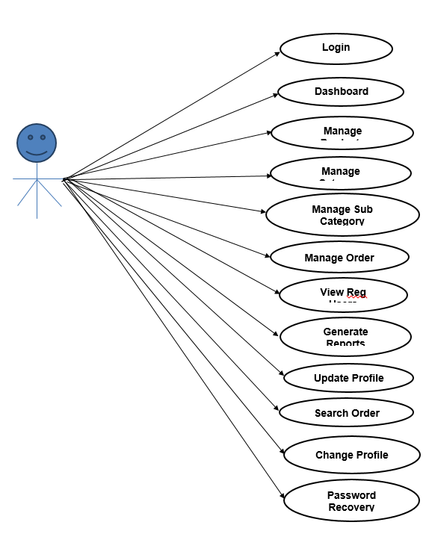

Figure 01: Use Case Diagram: Admin

#### User Case Diagram: Users

The user can log in to the system by using his specific email and password. Users can view the products and order the products according to their own needs. He can view his profile and update his details. He can update his personal information by logging into the system. Users can find various products by using the search option easily. update their details. He can update his personal information by logging into the system. Users can find various products by using the search option easily.

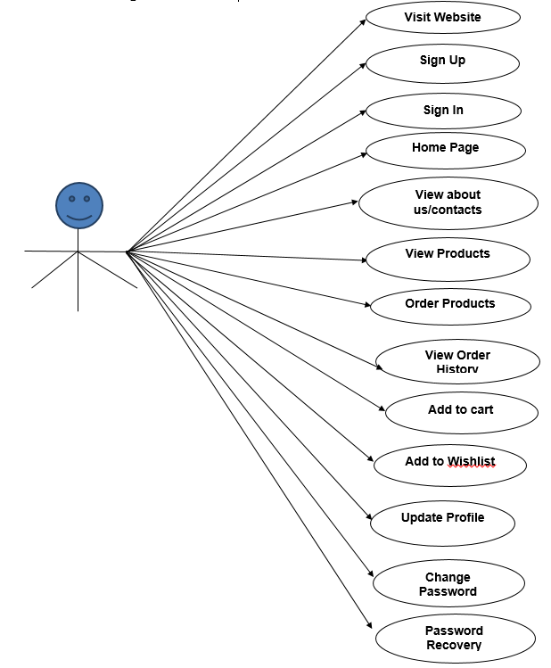

Figure 02: Use case diagram - User

The user can search products, Filter products, view Product images, check the specification of a product, view the reviews, able to handle the cart for checkout functionality.

#### Activity Diagram: User side

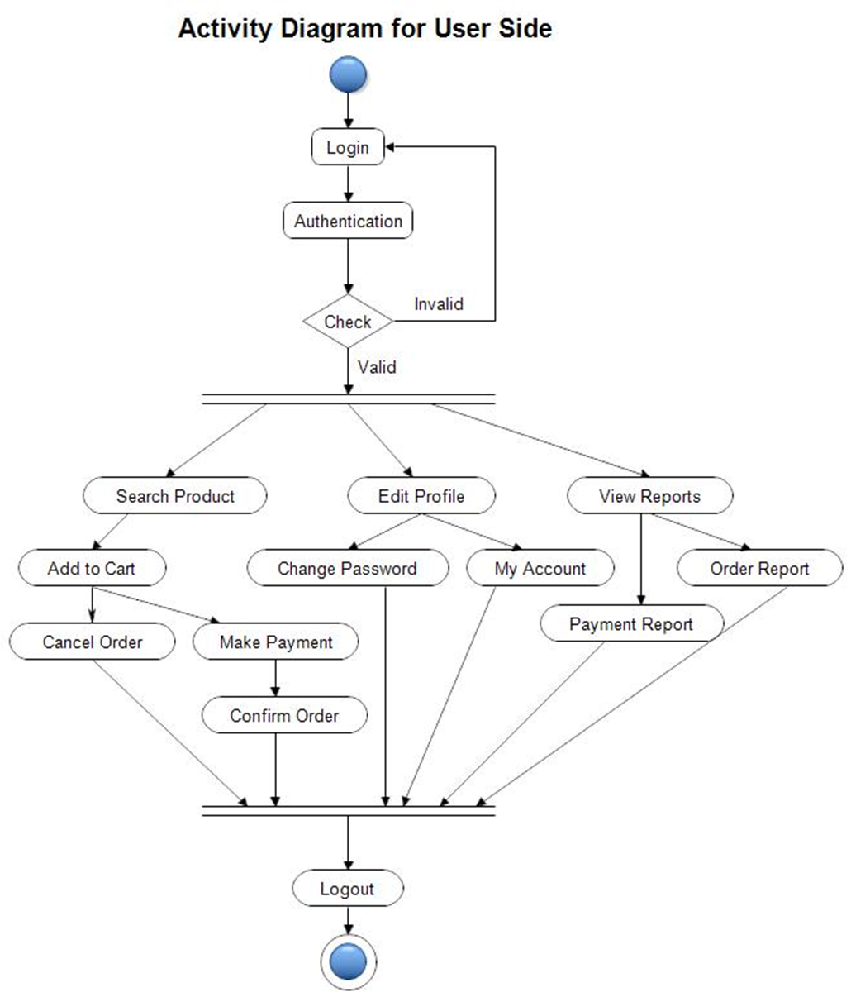

Figure 03: Activity Diagram: User side

#### Activity Diagram: Admin side

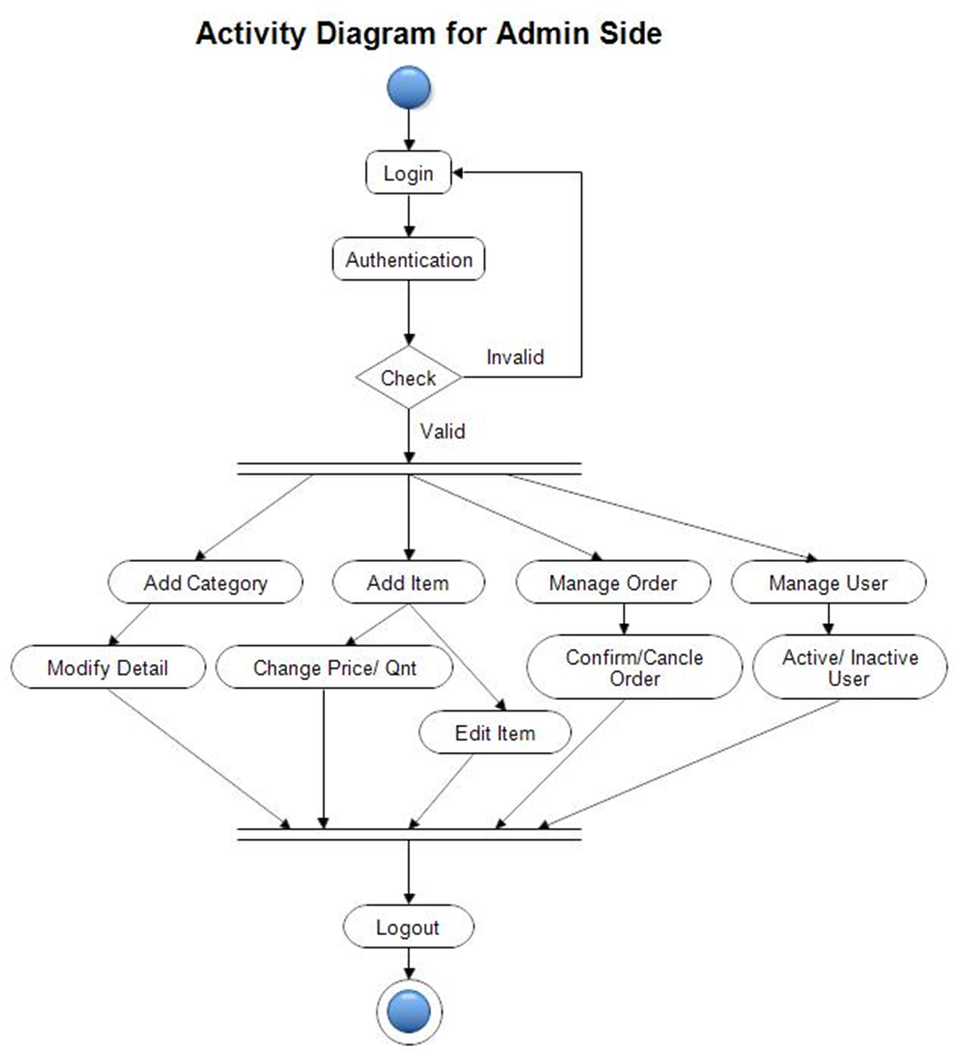

Figure 04: Activity Diagram: Admin side

#### COLLABORATION DIAGRAM:

A collaboration diagram is an introduction diagram that emphasizes the structural organization of the objects that send and receive messages. Graphically a collaboration diagram is a collection of vertices and arcs.

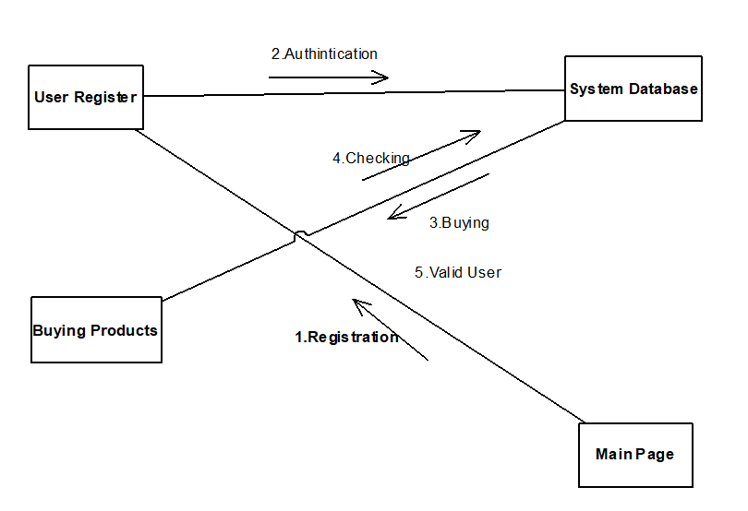

Figure 05: COLLABORATION DIAGRAM

#### CLASS DIAGRAM:

Class is nothing but a structure that contains both variables and methods. The Class Diagram shows a set of classes, interfaces, and collaborations and their relating ships. There is the most common diagram in modeling the object-oriented systems and used to give the static view of a system. It shows the dependency between the classes that can be used in our system.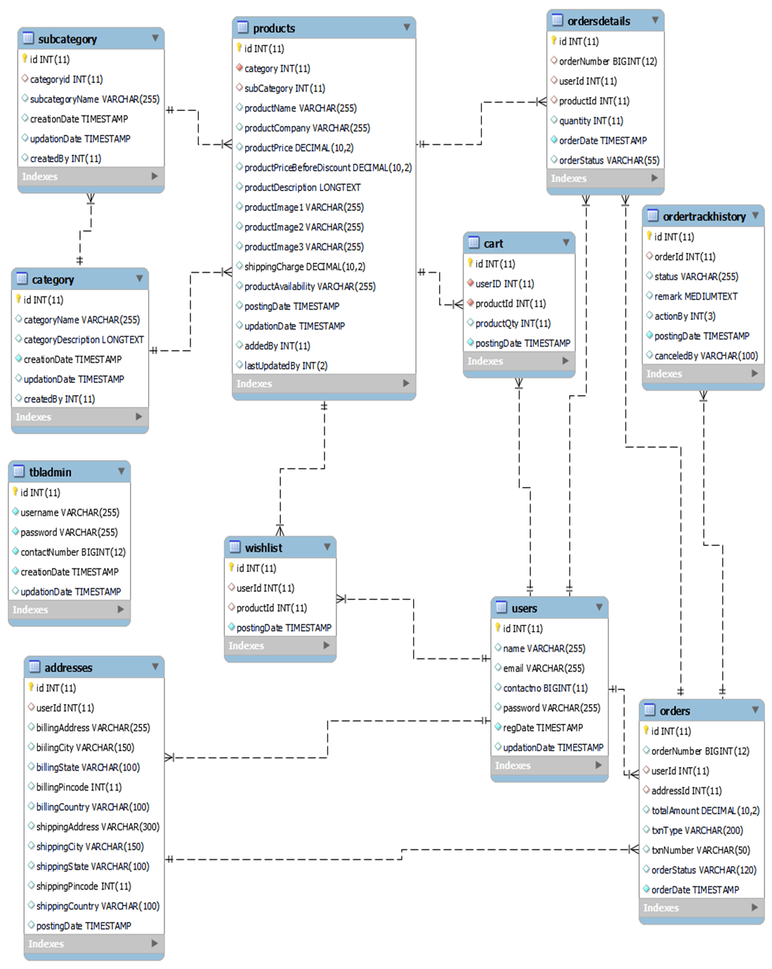

Figure 06: Class Diagram for E-Commerce

### 4.3 DATA FLOW DIAGRAMS:

The DFD takes an input-process-output view of a system i.e. data objects flow into the software, are transformed by processing elements, and resultant data objects flow out of the software. Data objects represented by labeled arrows and transformation are represented by circles also called as bubbles.

DFD is presented in a hierarchical fashion i.e., the first data flow model represents the system as a whole. Subsequent DFD refine the context diagram (level 0 DFD), providing increasing details with each subsequent level.

The DFD enables the software engineer to develop models of the information domain & functional domain at the same time. As the DFD is refined into greater levels of details, the analyst performs an implicit functional decomposition of the system. At the same time, the DFD refinement results in a corresponding refinement of the data as it moves through the process that embody the applications.

A context-level DFD for the system the primary external entities produce information for use by the system and consume information generated by the system. The labeled arrow represents data objects or object hierarchy.

#### Zero Level DFD:

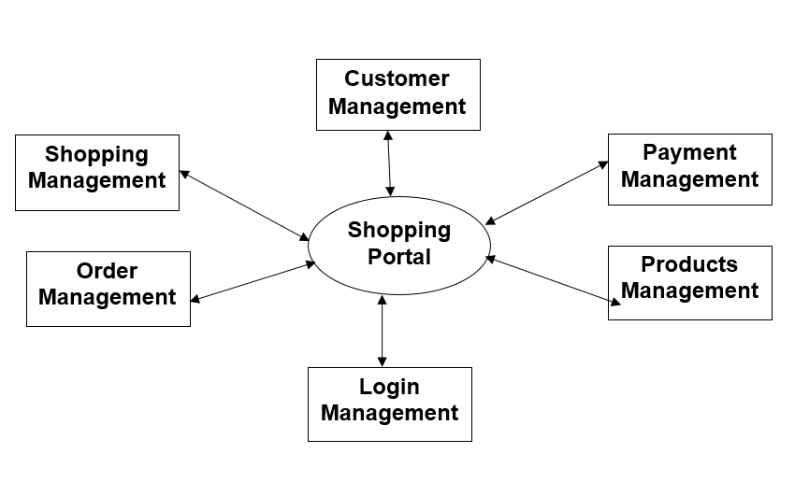

Figure 07: Zero Level DFD

#### First Level DFD:

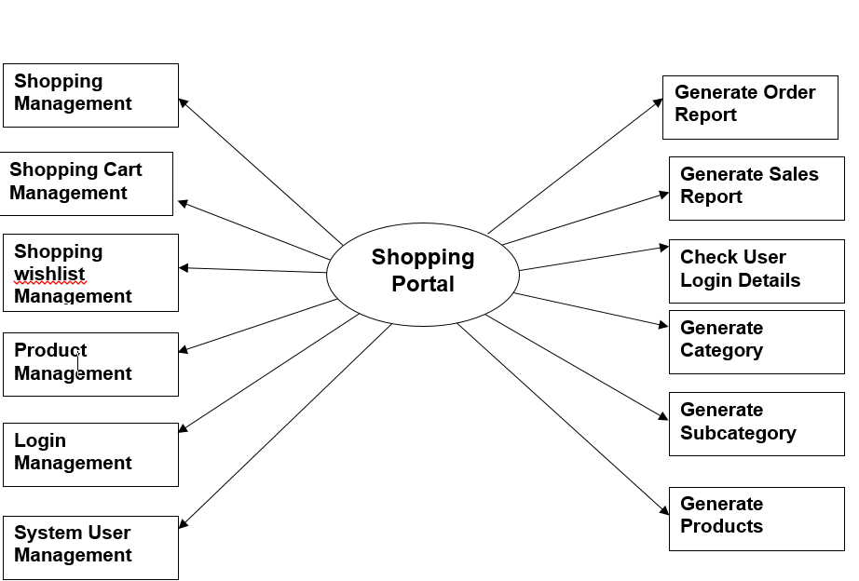

Figure 08: first Level DFD

#### 

#### 

#### 

#### 

#### Second level DFD: Admin

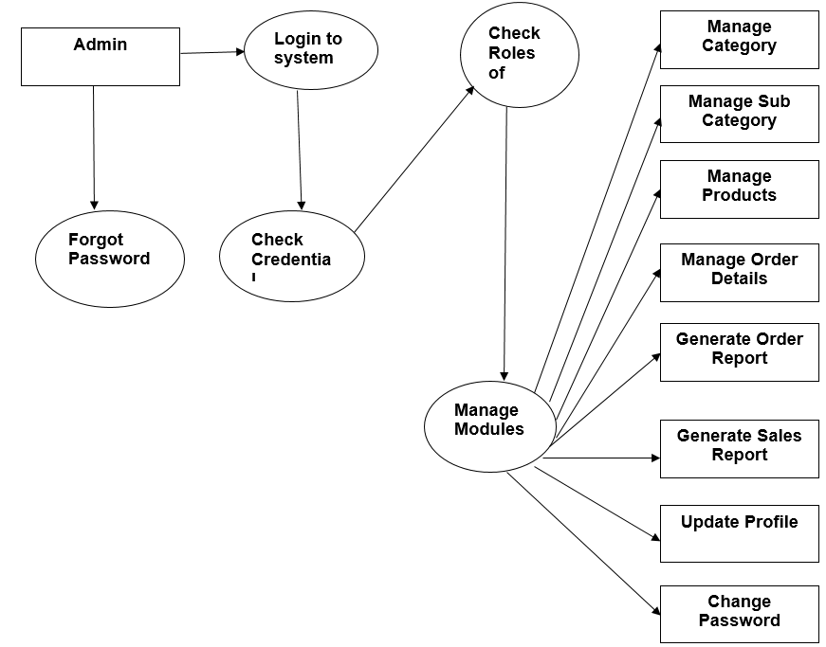

Figure 09: Second level DFD for Admin

#### 

#### 

#### 

#### 

#### Second level DFD: User

#### 

Figure 10: Second level DFD for User

### Chapter 5

## Database Design

Database design is the organization of data according to a database model. The designer determines what data must be stored and how the data elements interrelate. With this information, they can begin to fit the data into the database model. In this chapter, we will explain how we design our Database, ER Diagram, and tables.

### 5.1. ER Diagram

The Entity-Relationship (ER) model was originally proposed by Peter in 1976 [Chen76] as a way to unify the network and relational database views. Simply stated the ER model is a conceptual data model that views the real world as entities and relationships. A basic component of the model is the Entity-Relationship diagram which is used to visually represents data objects.

Since Chen wrote his paper the model has been extended and today it is commonly used for database design For the database designer, the utility of the ER model is:

* it maps well to the relational model. The constructs used in the ER model can easily be transformed into relational tables.
* it is simple and easy to understand with a minimum of training. Therefore, the model can be used by the database designer to communicate the design to the end-user.
* In addition, the model can be used as a design plan by the database developer to implement a data model in a specific database management software.

#### ER Notation

There is no standard for representing data objects in ER diagrams. Each modeling methodology uses its own notation. The original notation used by Chen is widely used in academics texts and journals but rarely seen in either CASE tools or publications by non-academics. Today, there are a number of notations used, among the more common are Bachman, crow's foot, and IDEFIX.

All notational styles represent entities as rectangular boxes and relationships as lines connecting boxes. Each style uses a special set of symbols to represent the cardinality of a connection. The notation used in this document is from Martin. The symbols used for the basic ER constructs are:

* **entities** are represented by labeled rectangles. The label is the name of the entity. Entity names should be singular nouns.
* **relationships** are represented by a solid line connecting two entities. The name of the relationship is written above the line. Relationship names should be verbs
* **attributes** when included, are listed inside the entity rectangle. Attributes which are identifiers are underlined. Attribute names should be singular nouns.
* **cardinality** of many is represented by a line ending in a crow's foot. If the crow's foot is omitted, the cardinality is one.
* **existence** is represented by placing a circle or a perpendicular bar on the line. Mandatory existence is shown by the bar (looks like a 1) next to the entity for an instance is required. Optional existence is shown by placing a circle next to the entity that is optional

### ER Diagram

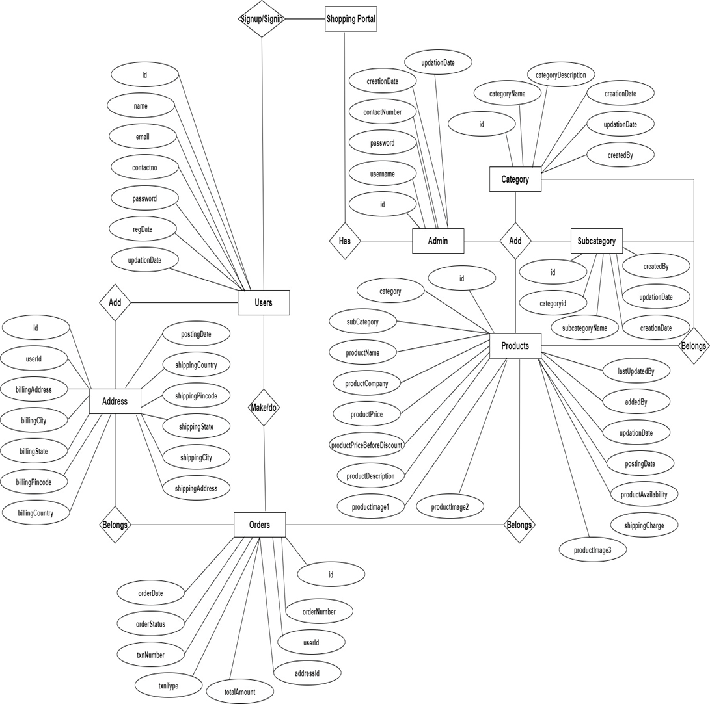

Figure 11: Entity Relationship Diagram

### 5.2.MySQL Data table

**Admin** Table :(Table name is tbladmin)

This table stores admin personal and login details.

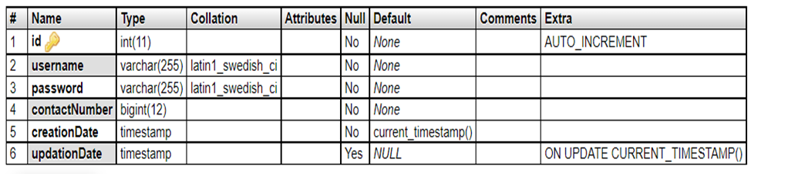

**Address** Table :(Table name is addresses)

This table stores the billing and shipping addresses of users.

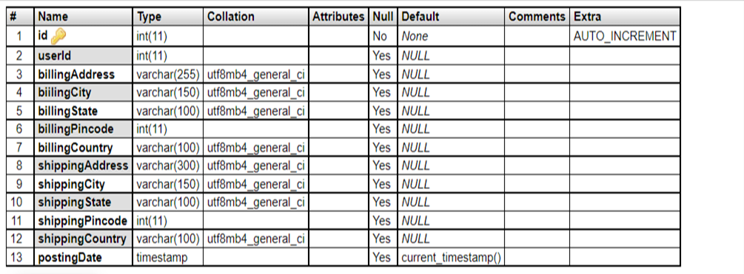

**Shopping** Table :(Table name is shopping)

This table stores the shopping details of users.

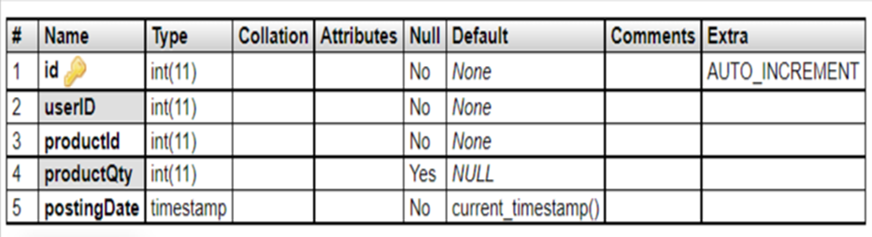

**Category** Table :(Table name is category)

This table stores the category of products.

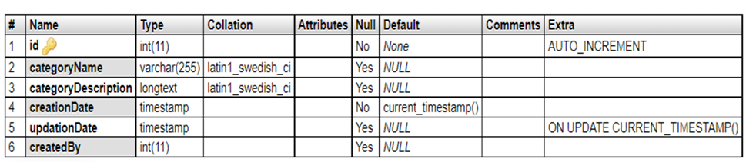

**Subcategory** Table :(Table name is subcategory)

This table stores the subcategory of products.

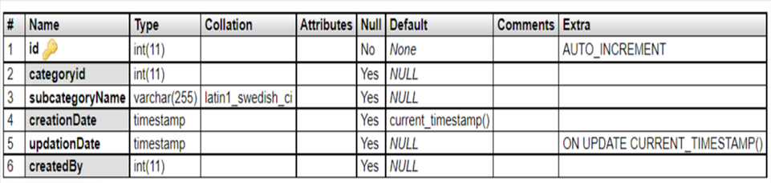

**Orders** Table :(Table name is orders)

This table stores the orders of users.

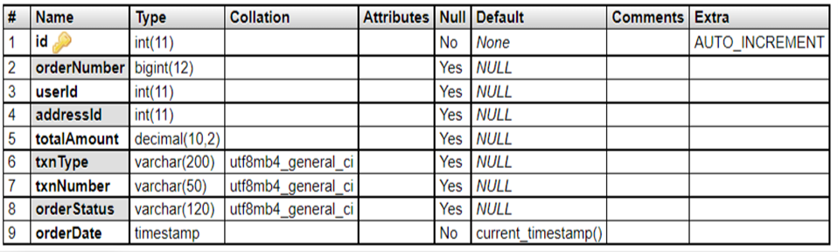

**Orders Details** Table :(Table name is ordersdetails)

This table stores the orders details of users.

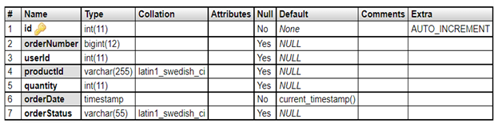

**Orders Tracking** Table :(Table name is ordertrackhistory)

This table store the data of order tracking history.

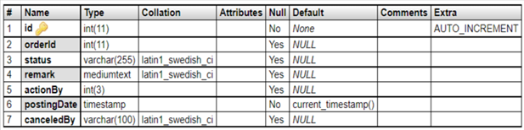

**Products Table** :(Table name is products)

This table store the data of products.

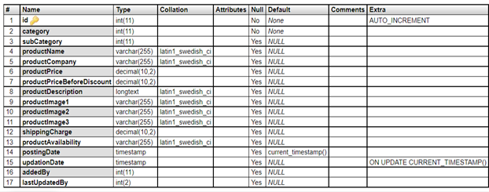

**User Table**:(Table name is users)

This table store the data of registered users.

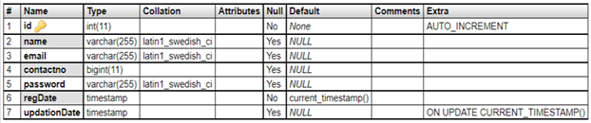

**Wishlist** Table: (Table name is wishlist)

This table store the wish-listed products of users.

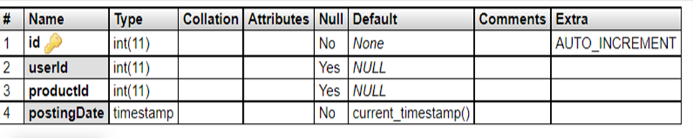

### Chapter 6

## Implementation and Experiment result

]This Chapter will contain details information about the development of the e-commerce System. To Develop Ecommerce, we will use HTML, CSS, AJAX, BOOTSTRAP, JavaScript for front End Design and Development. We will use MYSQL Database to Store information about sellers, admin products, and Other Data for better security of the System. The Product details appeared on the page from Database. The admin interface will contain all the accessibility to the Database such as editing customer information, adding or creating or editing products, managing order and order status, etc. The chapter will describe all the details related to developing our System

### 6.1. Modules and functionalities

**MODULES:** This project contains two modules, which are

* Admin
* User

#### MODULES DESCRIPTION:

#### Admin Modules

This module provides administrator-related functionalities. The administrator manages the entire application.

**Dashboard:** In this section, the admin can briefly view the total orders, total new orders, total packed orders, total dispatched orders, total in-transit orders, total out for delivery orders, total delivered, total canceled, and total registered users.

**Category:** In this section, admin can manage category of products(add/update/delete).

**Subcategory:** In this section, admin can manage subcategory of products (add/update/delete).

**Products:** In this section, admin can manage products (add/update/delete).

**Orders:** In this section, admin can view the mobile order details and they have also the right to change order status according to current status.

**Search Order:** In this section, admin can search particular order with the help of the order number.

**Reports:** In this section admin can view order details and sales reports according to dates.

**Registered Users:** In this section, the admin can view registered users.

Admin can also update his profile, change the password and recover the password.

#### User Module

1. **Shop:** In this section, users can view which products is available on the website
2. **My Accounts:** In this section, users can his/her password, view and update his/her profile and log out from accounts.
3. **My orders**: In this section, users can view order history after login.
4. **Cart:** In this section, the user can add the products which he/she want to order.
5. **Wishlist:** In this section, the user can add products to the Wishlist.
6. **Order management:** The user has also a facility to download his/her invoice and cancel orders if he/she wants to cancel.

#### System functionalities

On this page guest users (users who are not registered) can view the products, search for products according to name and brand name. Guest users can also sign up and the registered users can sign in. User can also track their order without login.

The system will contain each of the elements of the page as a section. Such as header section, footer section, product grid section, product list section, product information section, Login section registration section, cart section, etc. for the user interface.

The Database System contains a group of tables to store and manipulate the data to the whole system. The System will contain a User table, admin table, Product table, order table, staff information table, and so on.

The Admin system contains a Dashboard to track the order and manipulate the products and their categories. It also contains each section as a page for faster loading of the system.

### 6.2. Testing

Testing is a process of executing a program with the indent of finding an error. Testing is a crucial element of software quality assurance and presents ultimate review of specification, design and coding.

System Testing is an important phase. Testing represents an interesting anomaly for the software. Thus, a series of testing are performed for the proposed system before the system is ready for user acceptance testing.

A good test case is one that has a high probability of finding an as undiscovered error. A successful test is one that uncovers an as undiscovered error.

#### Testing Objectives:

* Testing is a process of executing a program with the intent of finding an error
* A good test case is one that has a probability of finding an as yet undiscovered error
* A successful test is one that uncovers an undiscovered error

#### Testing Principles:

* All tests should be traceable to end user requirements
* Tests should be planned long before testing begins
* Testing should begin on a small scale and progress towards testing in large
* Exhaustive testing is not possible
* To be most effective testing should be conducted by a independent third party

#### System testing:

System testing tests the integration of each module in the system. It also tests to find discrepancies between the system and it’s original objective, current specification and system documentation. The primary concern is the compatibility of individual modules. Entire system is working properly or not will be tested here, and specified path ODBC connection will correct or not, and giving output or not are tested here these verifications and validations are done by giving input values to the system and by comparing with expected output. Top-down testing implementing here.

#### Acceptance Testing:

This testing is done to verify the readiness of the system for the implementation. Acceptance testing begins when the system is complete. Its purpose is to provide the end user with the confidence that the system is ready for use. It involves planning and execution of functional tests, performance tests and stress tests in order to demonstrate that the implemented system satisfies its requirements.

Tools to special importance during acceptance testing include:

**Test coverage Analyzer –** records the control paths followed for each test case.

**Timing Analyzer –** also called a profiler, reports the time spent in various regions of the code are areas to concentrate on to improve system performance.

**Coding standards –** static analyzers and standard checkers are used to inspect code for deviations from standards and guidelines.

### System Testing For Ecommerce:

#### General Test Cases:

* we verify that the user is able to navigate through all the products across different categories.
* we verify that all the links and banners are redirecting to correct product/category pages and none of the links are broken.
* we verify that the company logo is clearly visible.
* we verify that all the text – product, category name, price, and product description are clearly visible.
* we verify that all the images – product and banner are clearly visible.
* we verify that category pages have a relevant product listed specific to the category.
* we verify that the correct count of total products is listed on the category pages.

#### Product Buy Flow – Test cases:

* we verify that on the product page, the user can select the desired attribute of the product e.g. size, color, etc.
* we verify that the user can add to cart one or more products.
* we verify that users can add products to the wishlist.
* we verify that the user can buy products added to the cart after signing in to the application (or as per the functionality of the website).
* we verify that the user can successfully buy more than one product that was added to his/her cart.
* we verify that the user cannot add more than the available inventory of the product.
* we verify that the limit to the number of products a user can buy is working correctly by displaying an error message and preventing the user from buying more than the limit.
* we verify that the delivery can be declined for the places where shipping is not available.

#### 

#### User(Buyer) Registration – Test cases

* we verify that all the specified fields are present on the registration page.
* we verify that the required/mandatory fields are marked with * against the field.
* we verify that for better user interface dropdowns, radio buttons and checkboxes, etc fields are displayed wherever possible instead of just textboxes
* we verify the page has both submit and cancel/reset buttons at the end.
* we verify that clicking submits button after entering all the required fields, submits the data to the server.
* we verify that whenever possible validation should take place at client side
* we verify that not filling the mandatory fields and clicking the submit button will lead to validation error.
* we verify that not filling the optional fields and clicking the submit button will still send data to the server without any validation error.

#### Admin – Product creation Test cases

* we verify that authenticated Admin get access to product creation panels specific to the authorized categories.
* we verify that the product creation panel is working fine for single product creation.
* we verify that the product creation panel is working fine for multiple product creations.
* we verify that the maximum product creation limit for the seller is working fine, limiting the seller to create more than the desired number of products.
* we verify panel validation for checking mandatory fields.
* we verify that duplicate product creation is restricted through the panel.
* we verify that seller can update the information and price of existing products.
* we verify that products created by sellers get visible on the website after a certain period of time.
* we verify that updates made by the seller get visible on the website after a certain period of time.

### 

### 6.3. System Output Screen : User interface

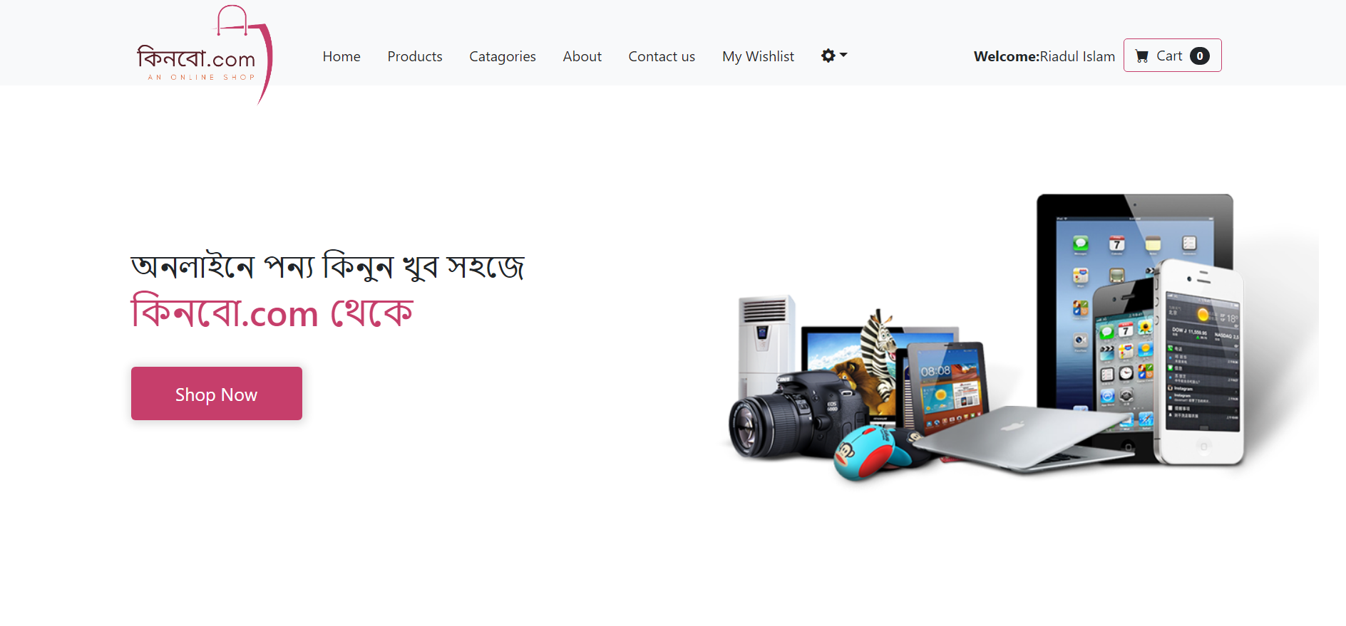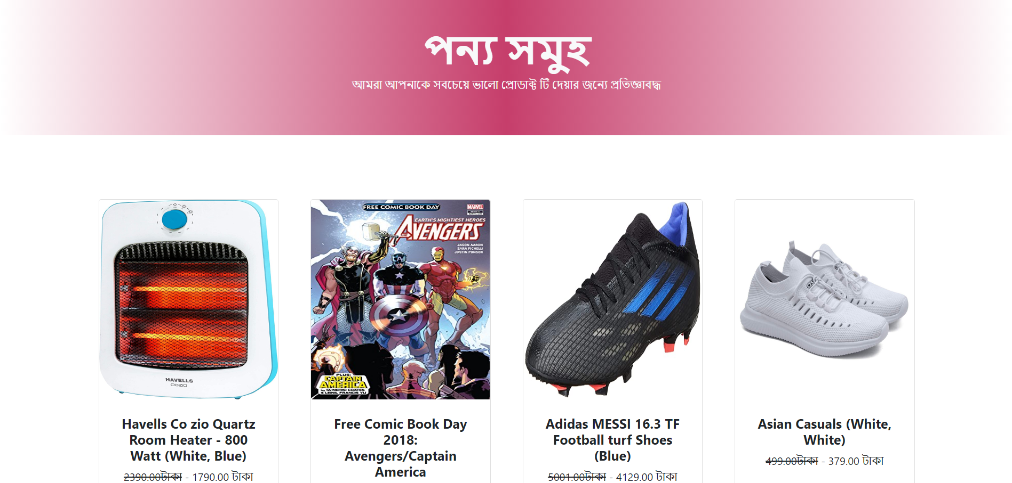

Homepage

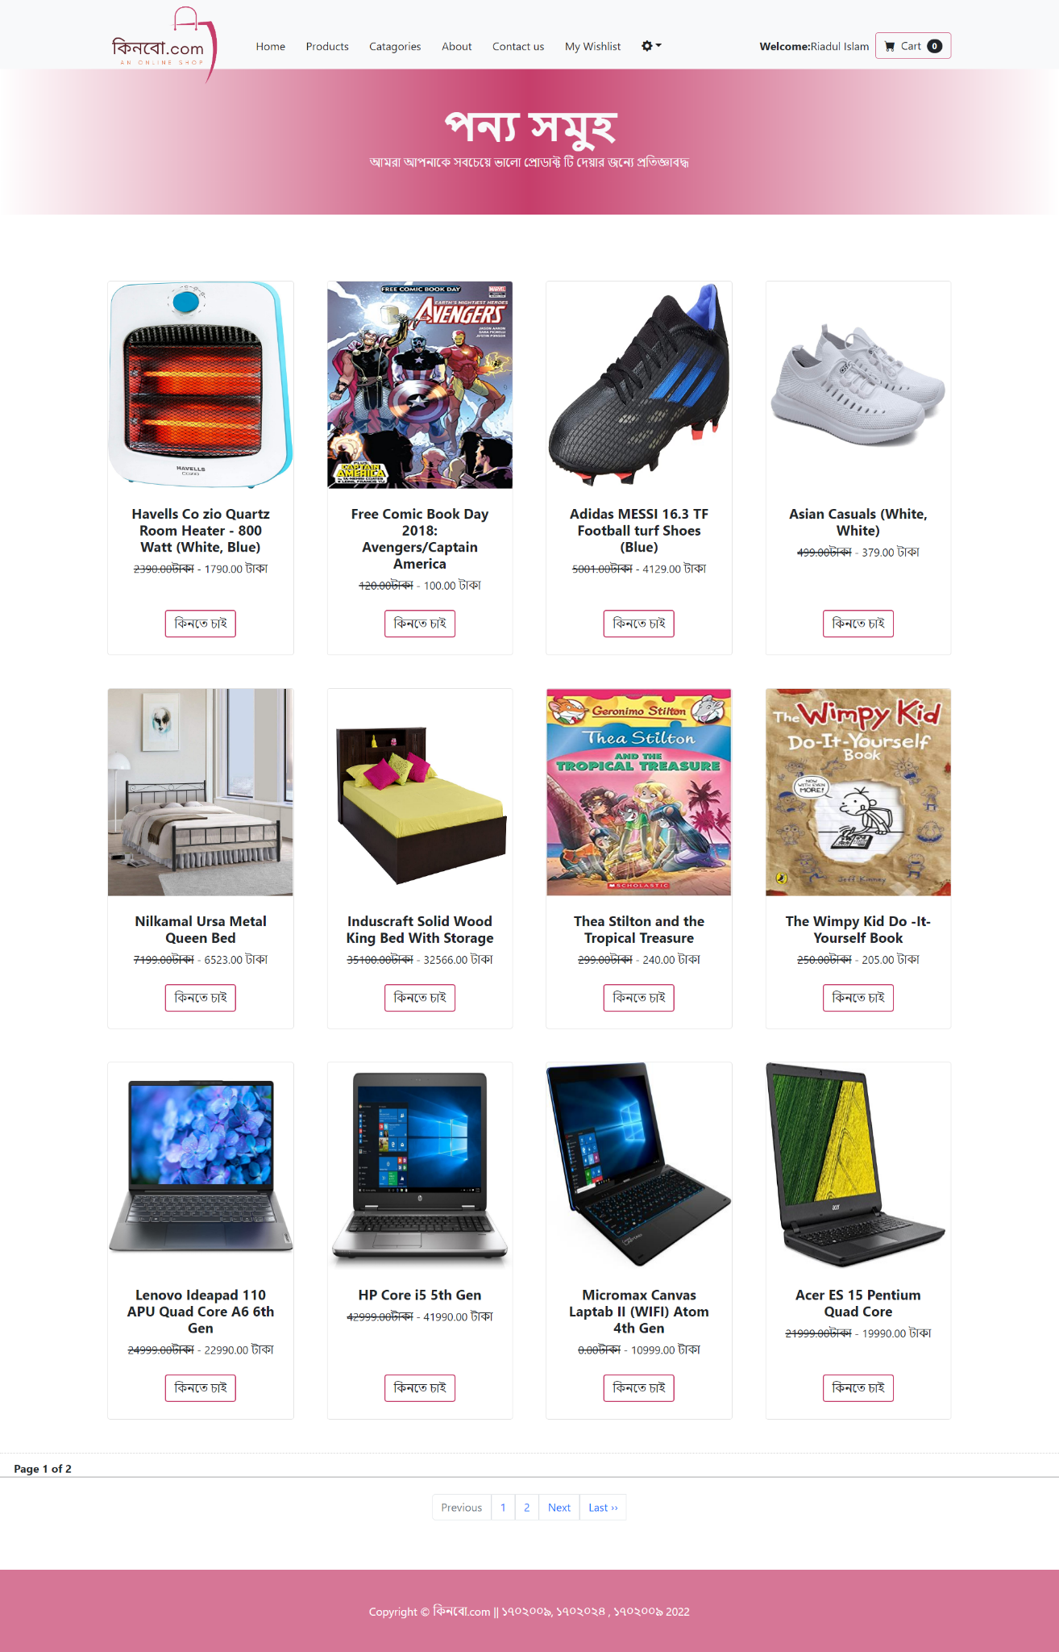

Products page

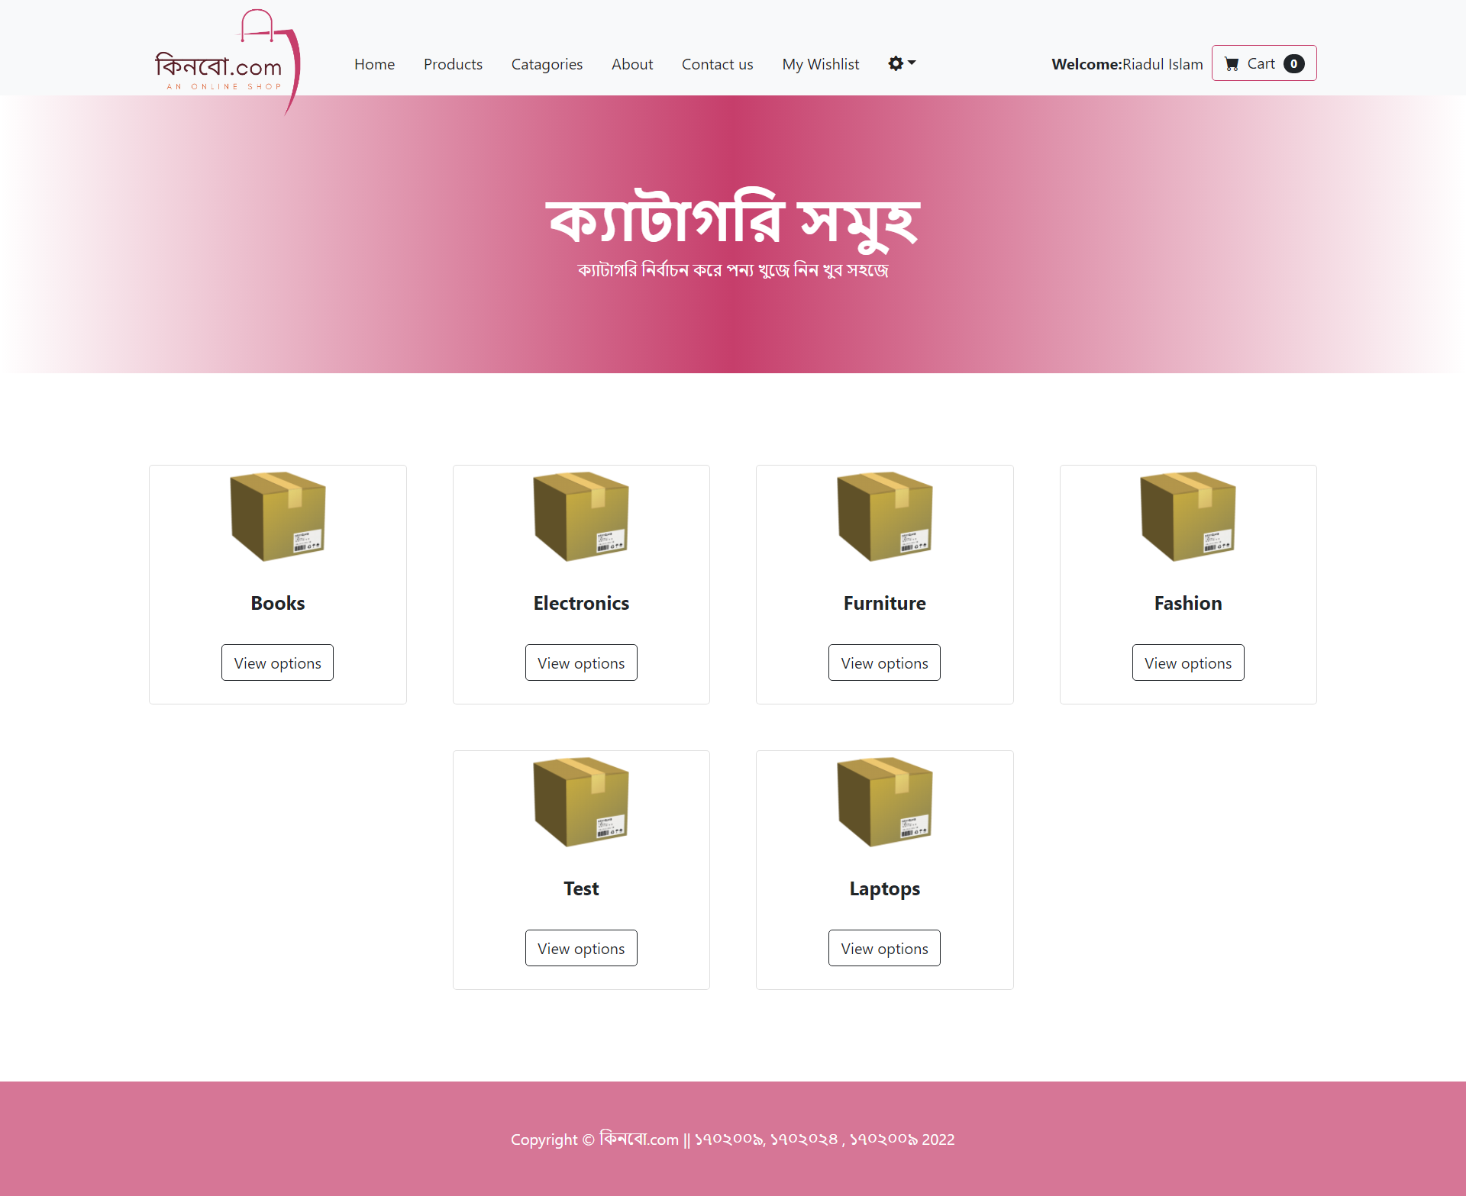

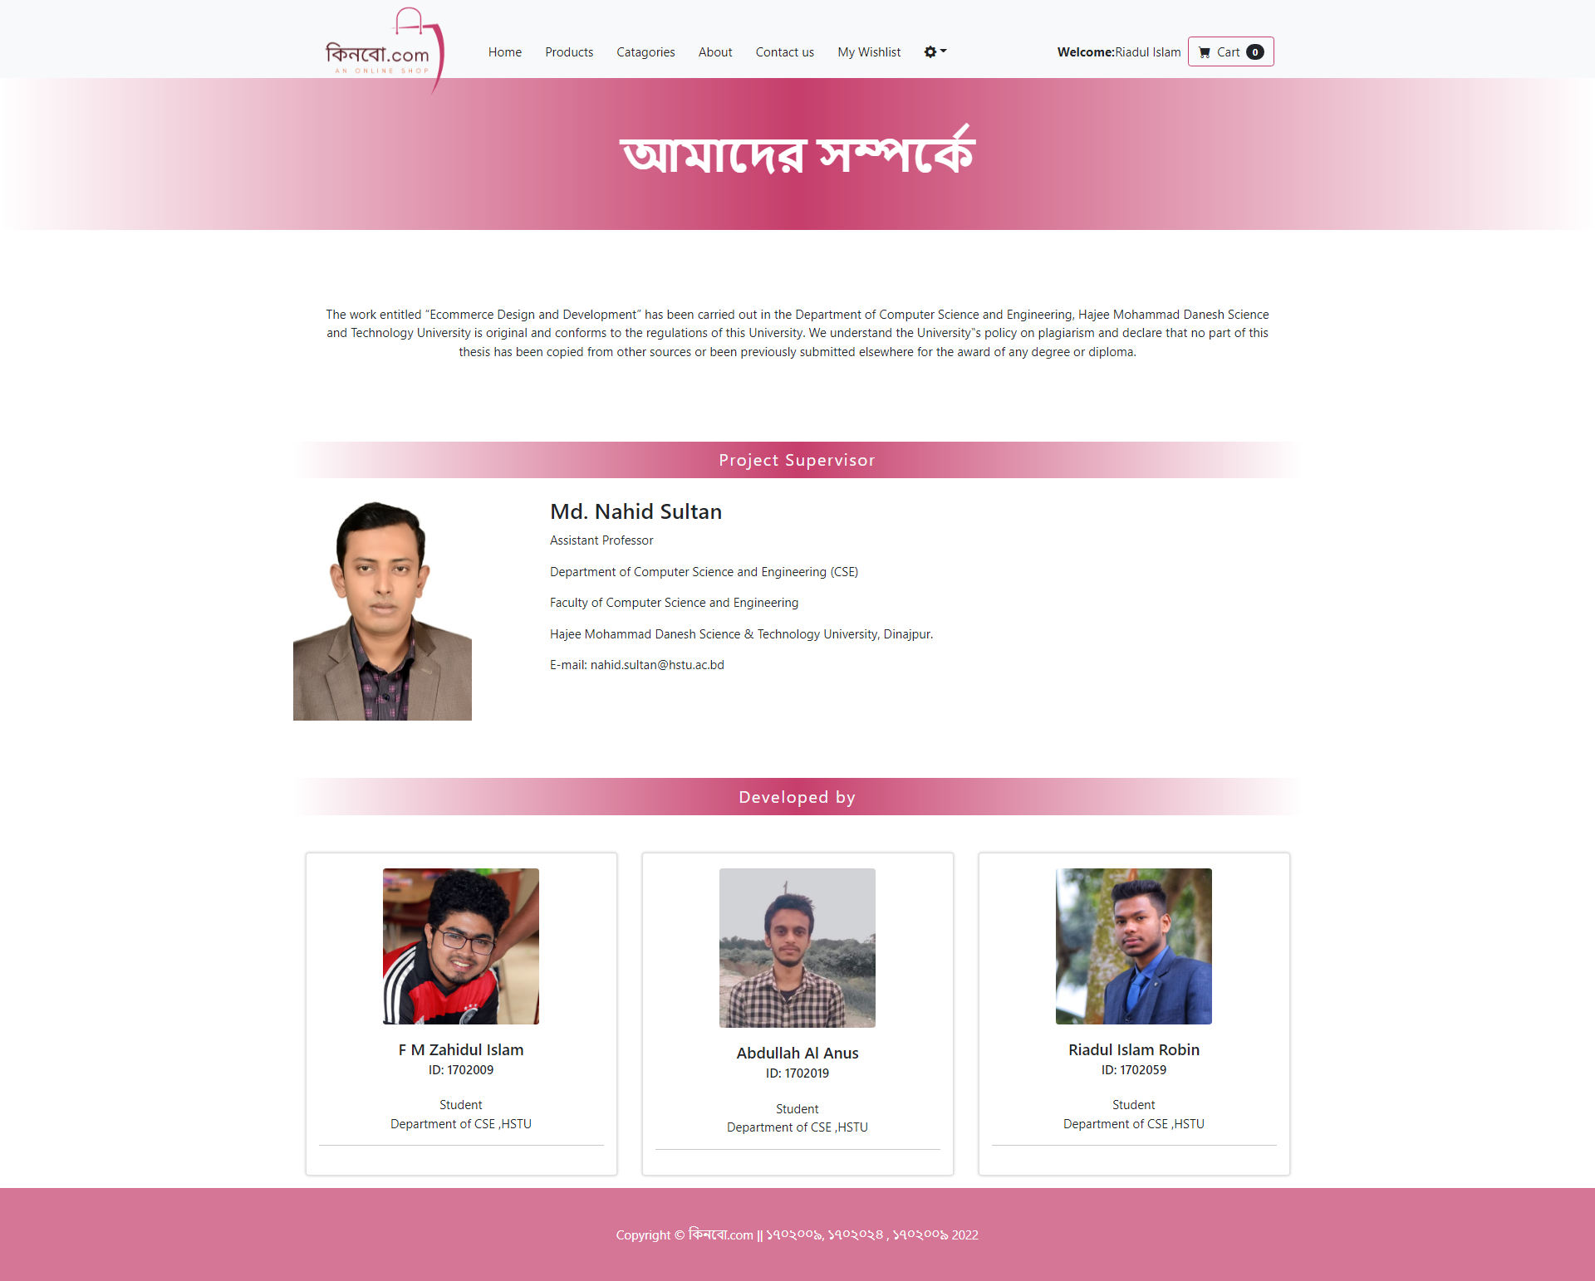

About us

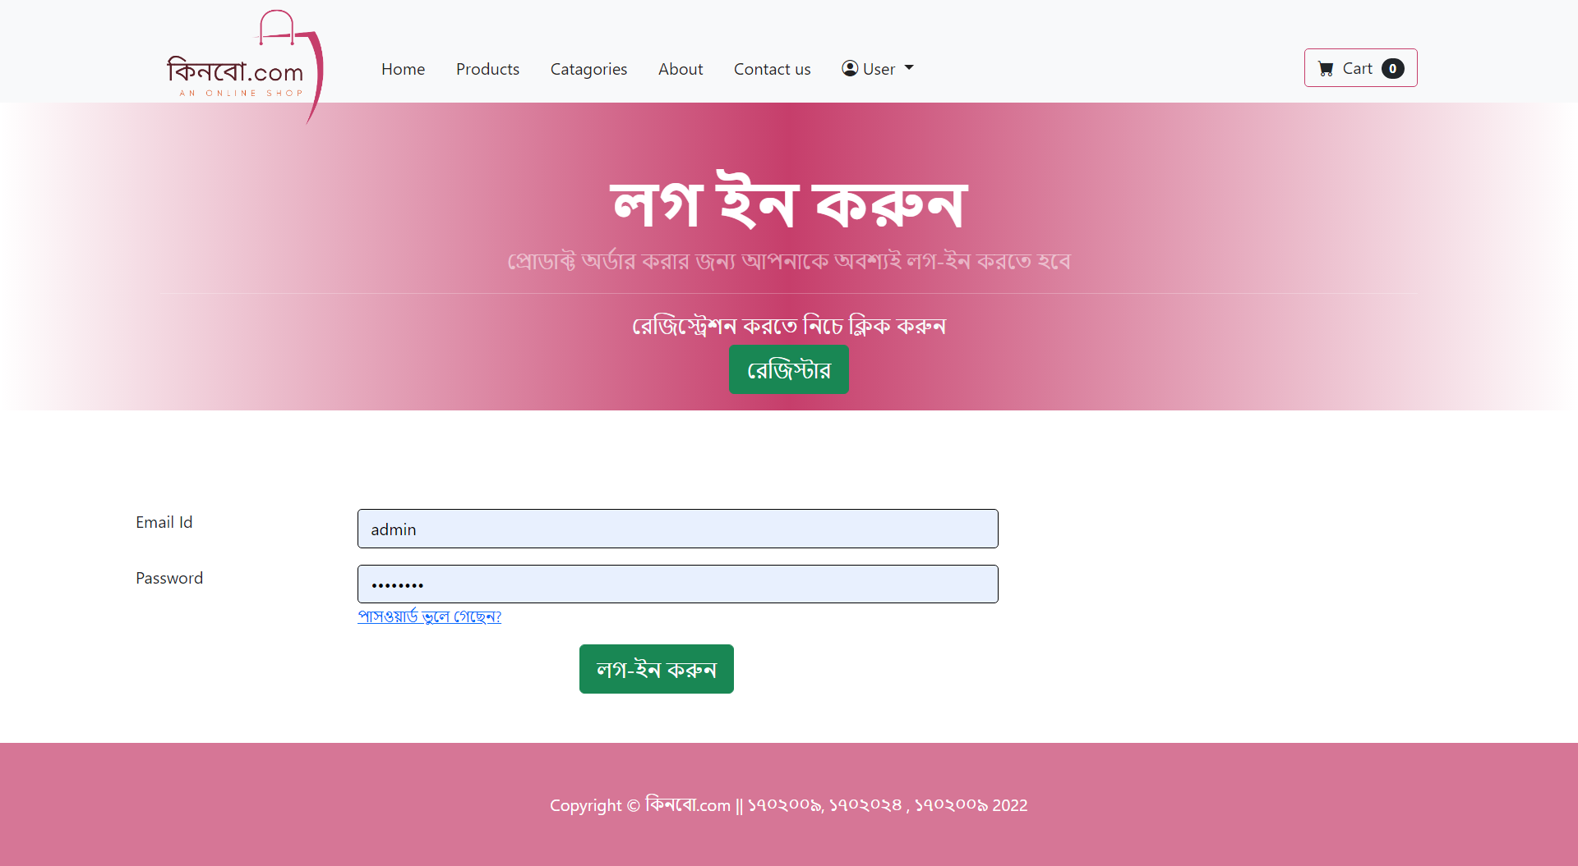

Login page

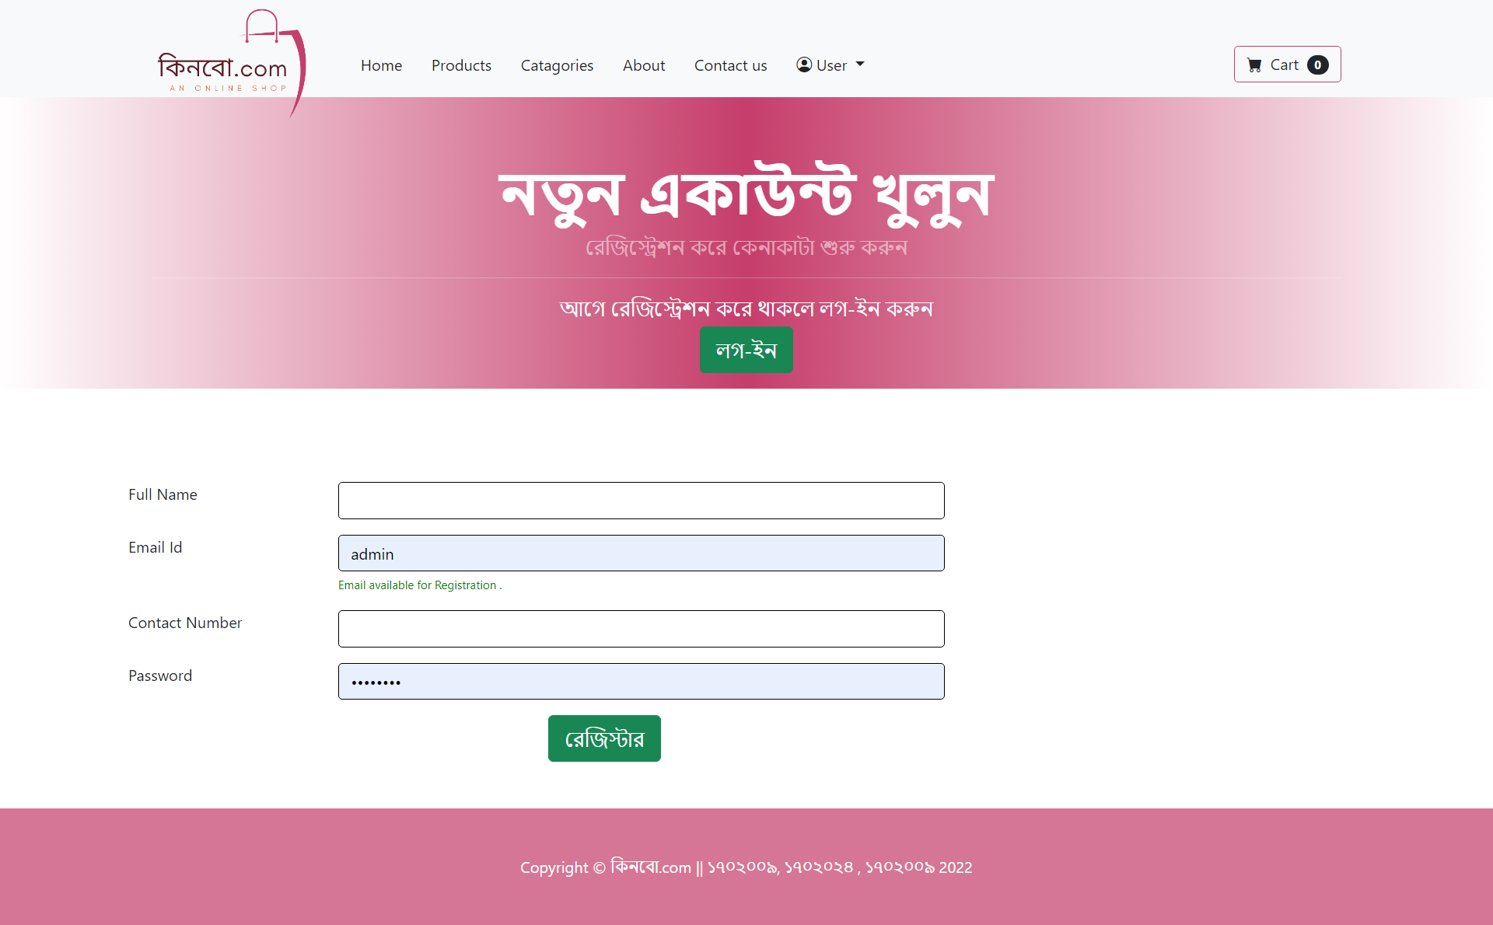

Registration page

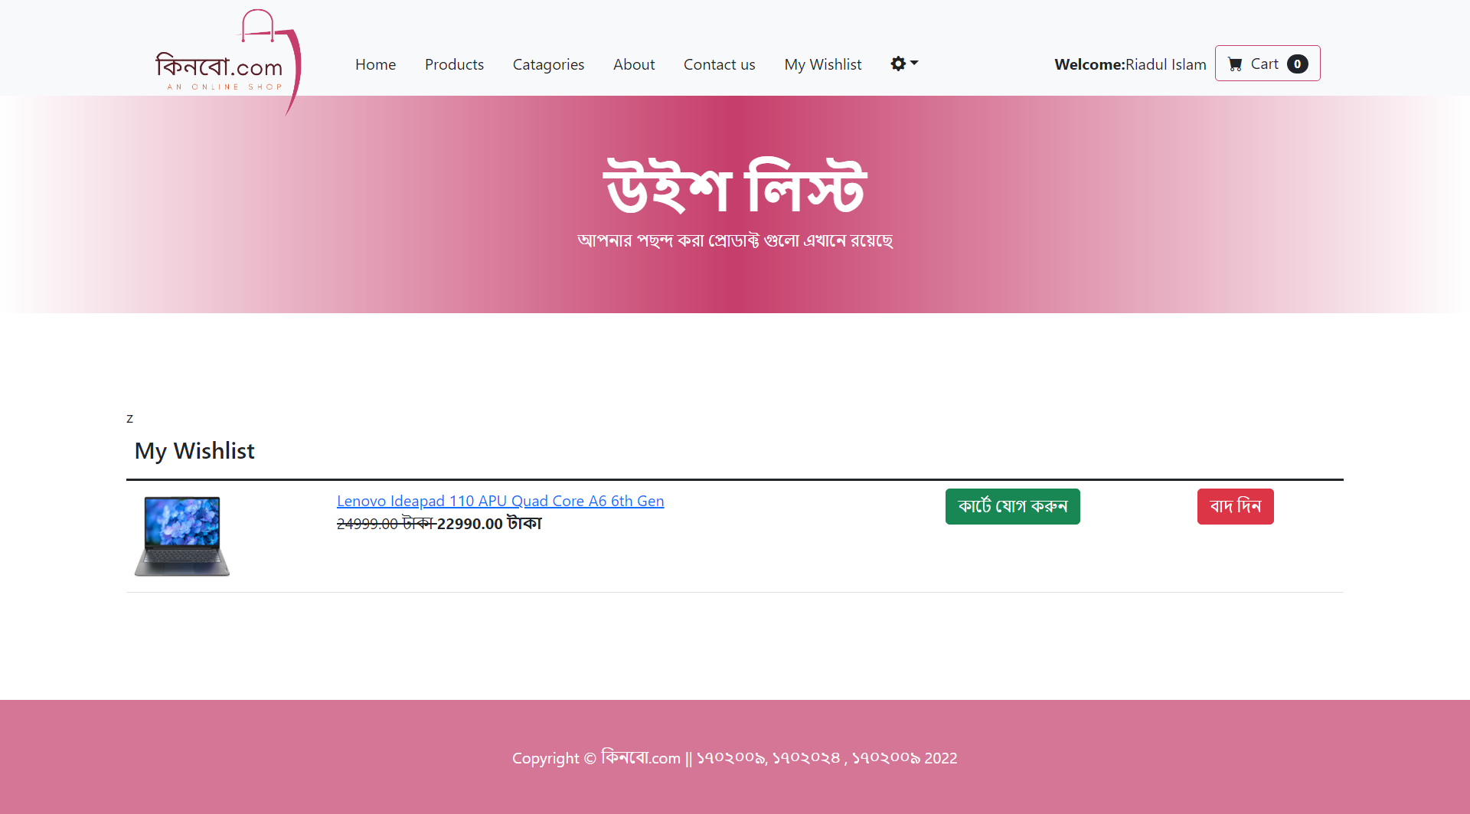

Wishlist

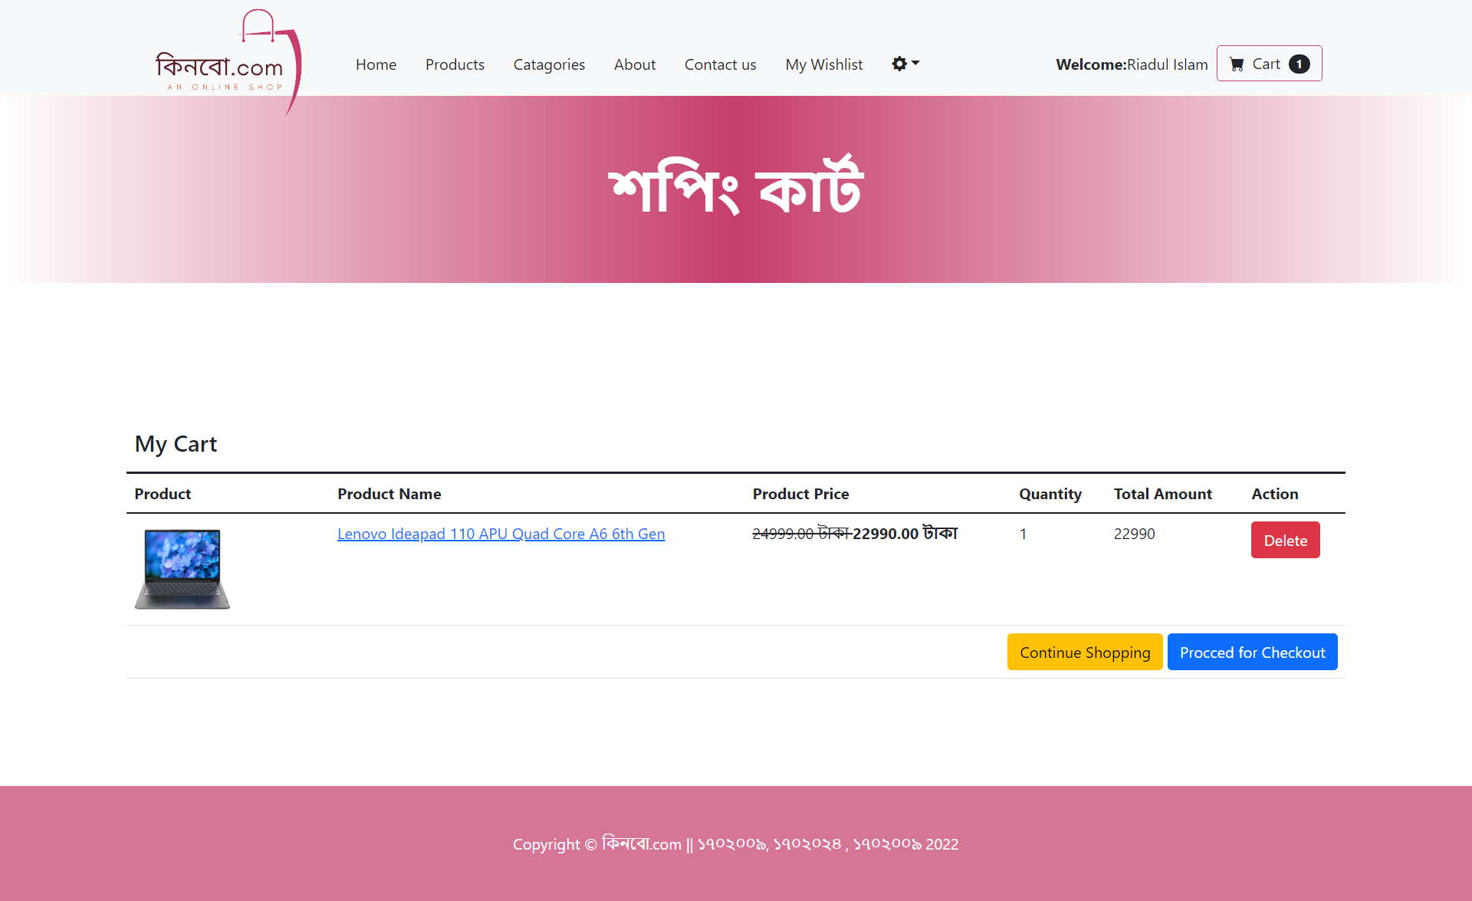

Shopping Cart

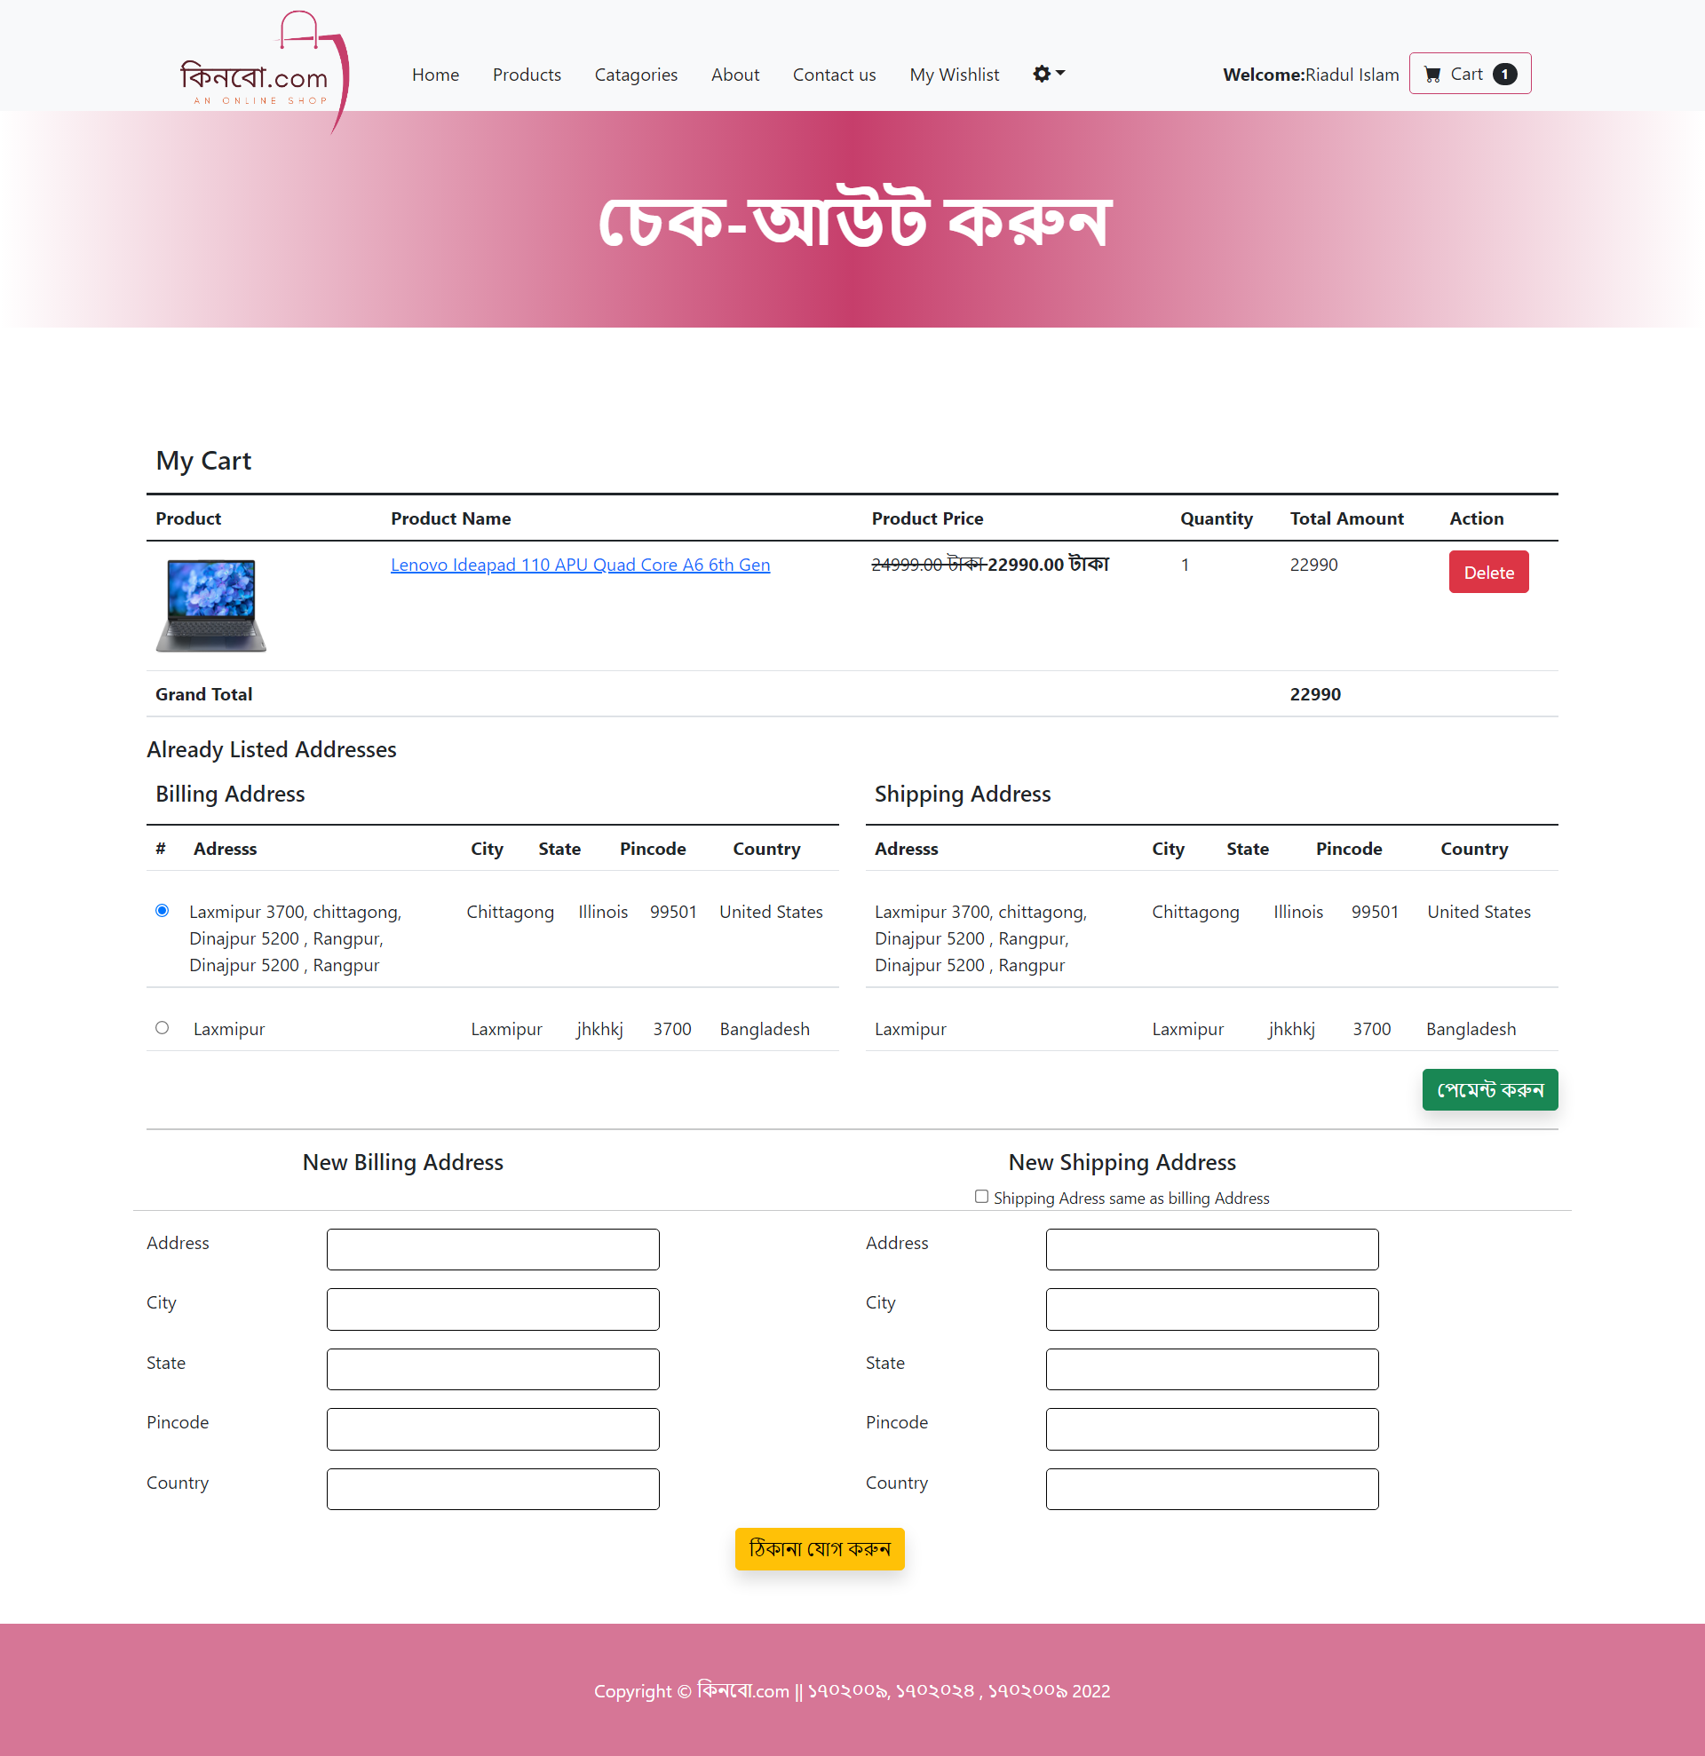

Check Out

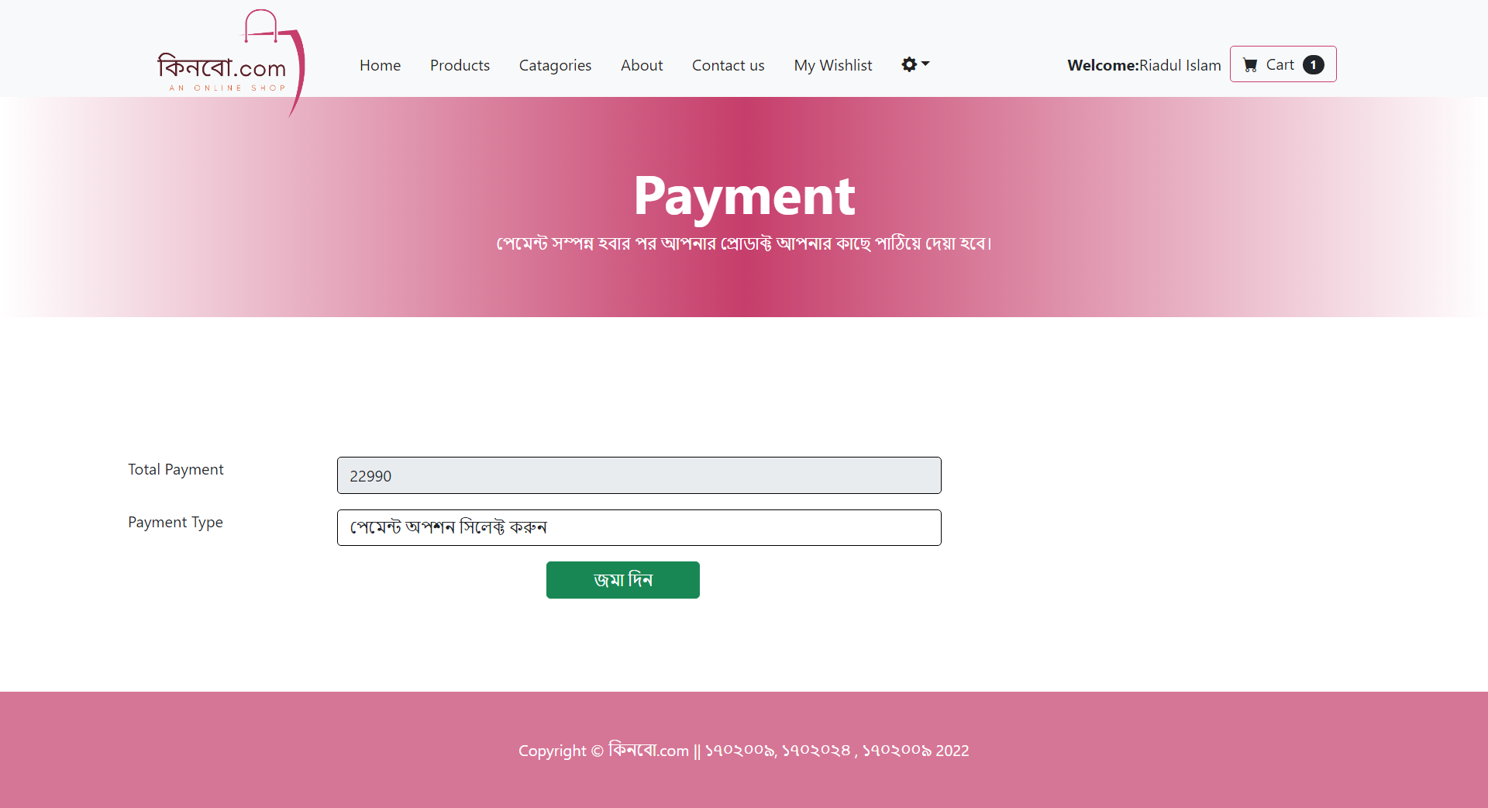

Payment

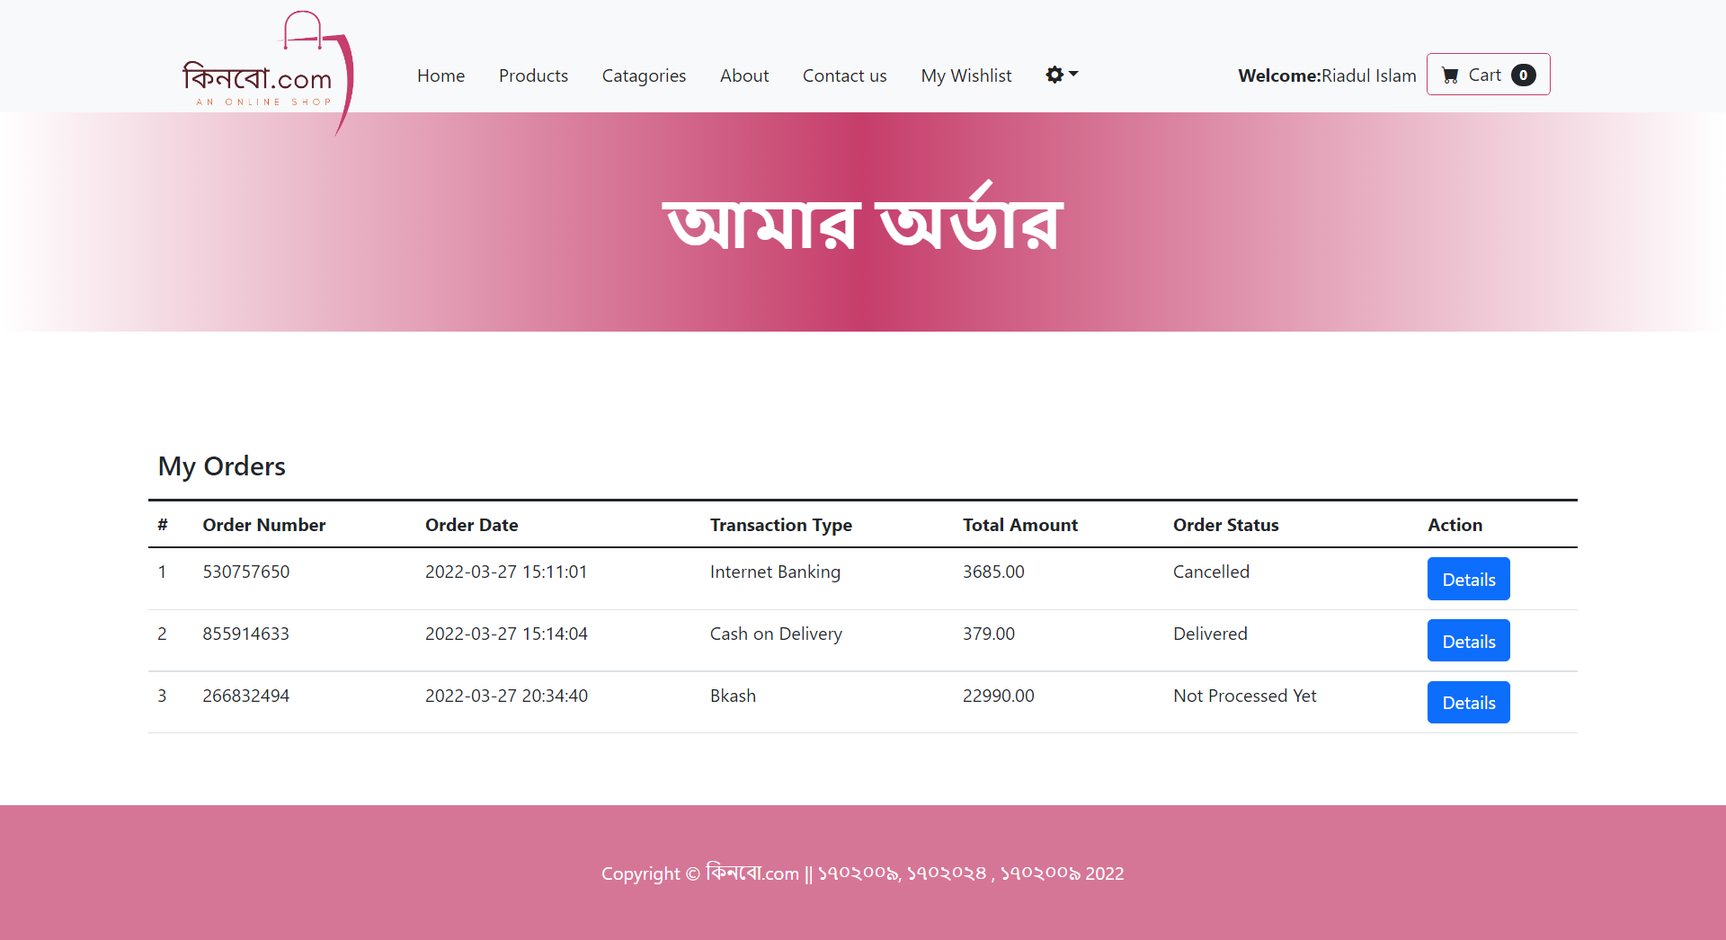

My Order

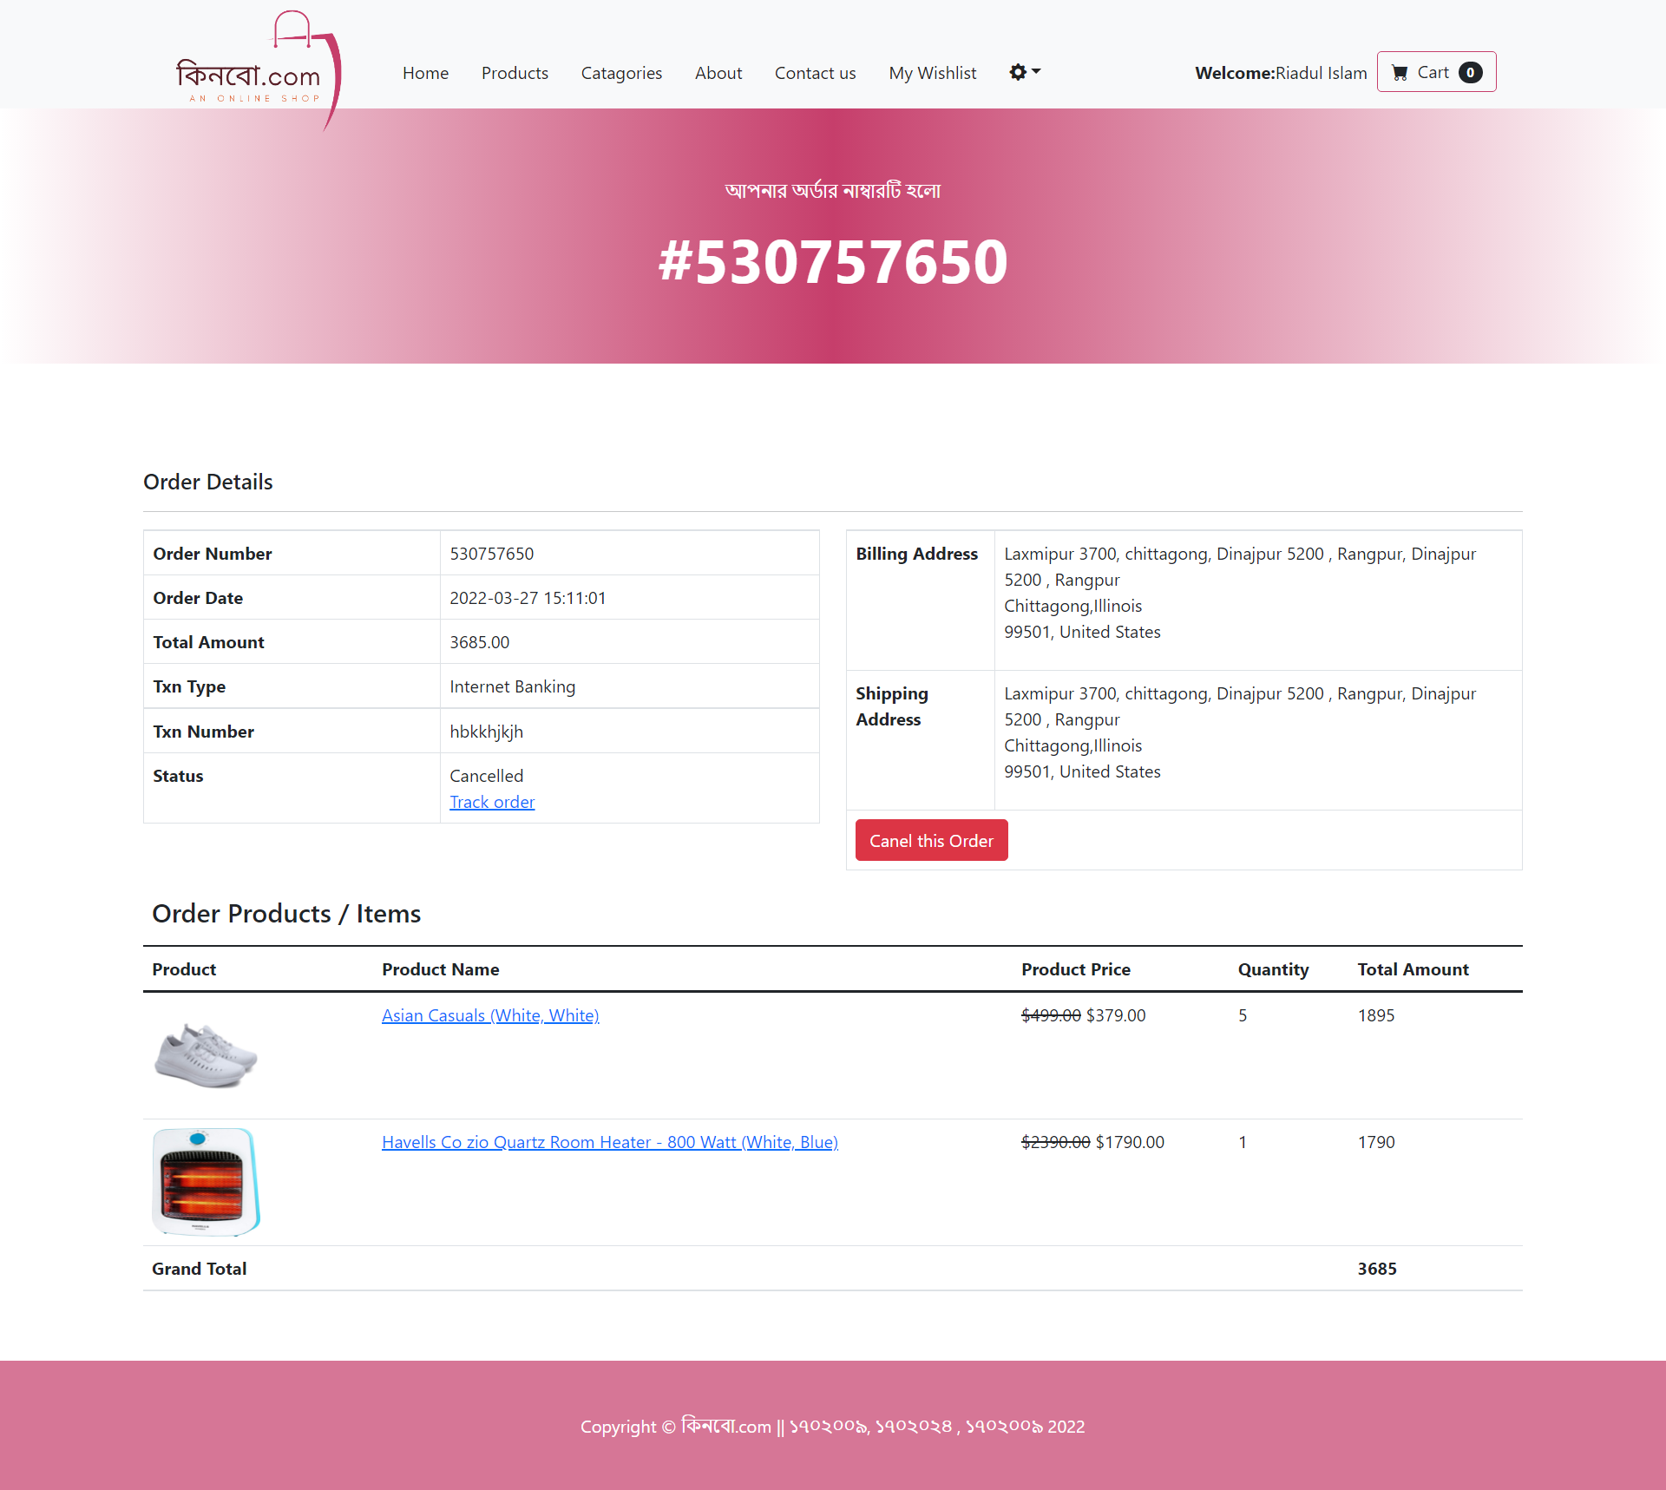

Order Tracking

### System screen output : admin

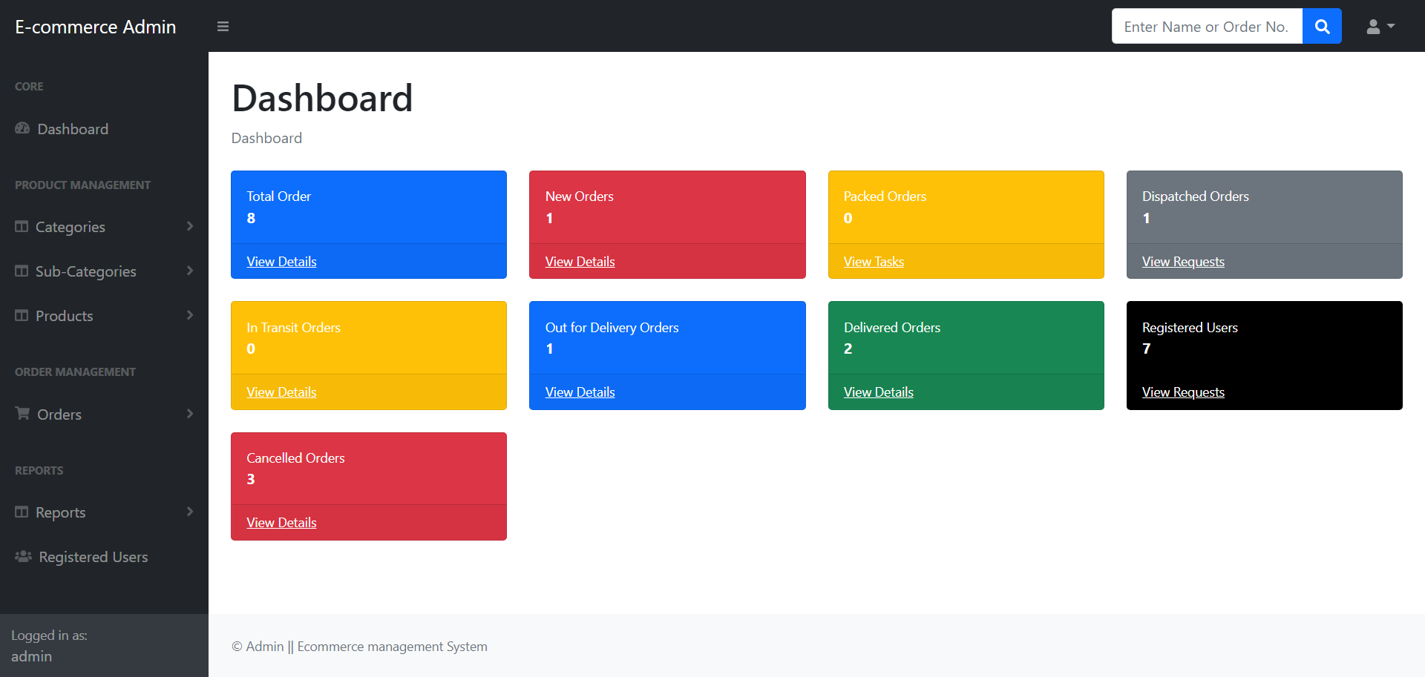

Dashboard

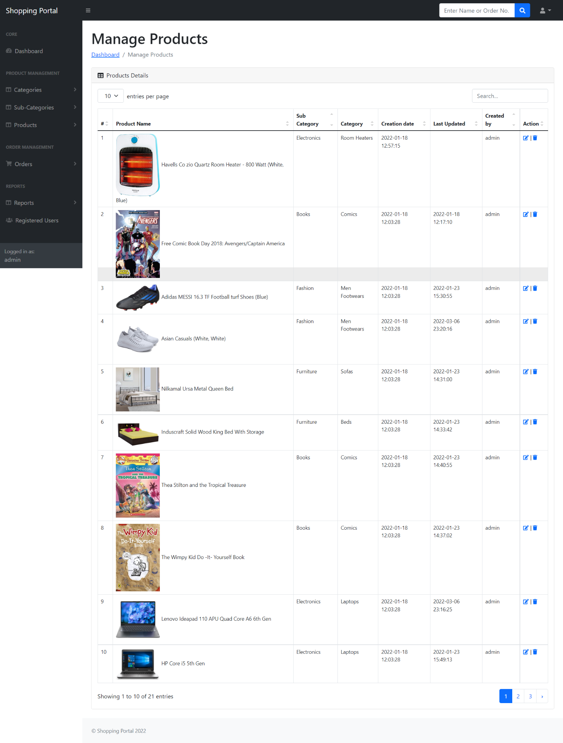

Product manager

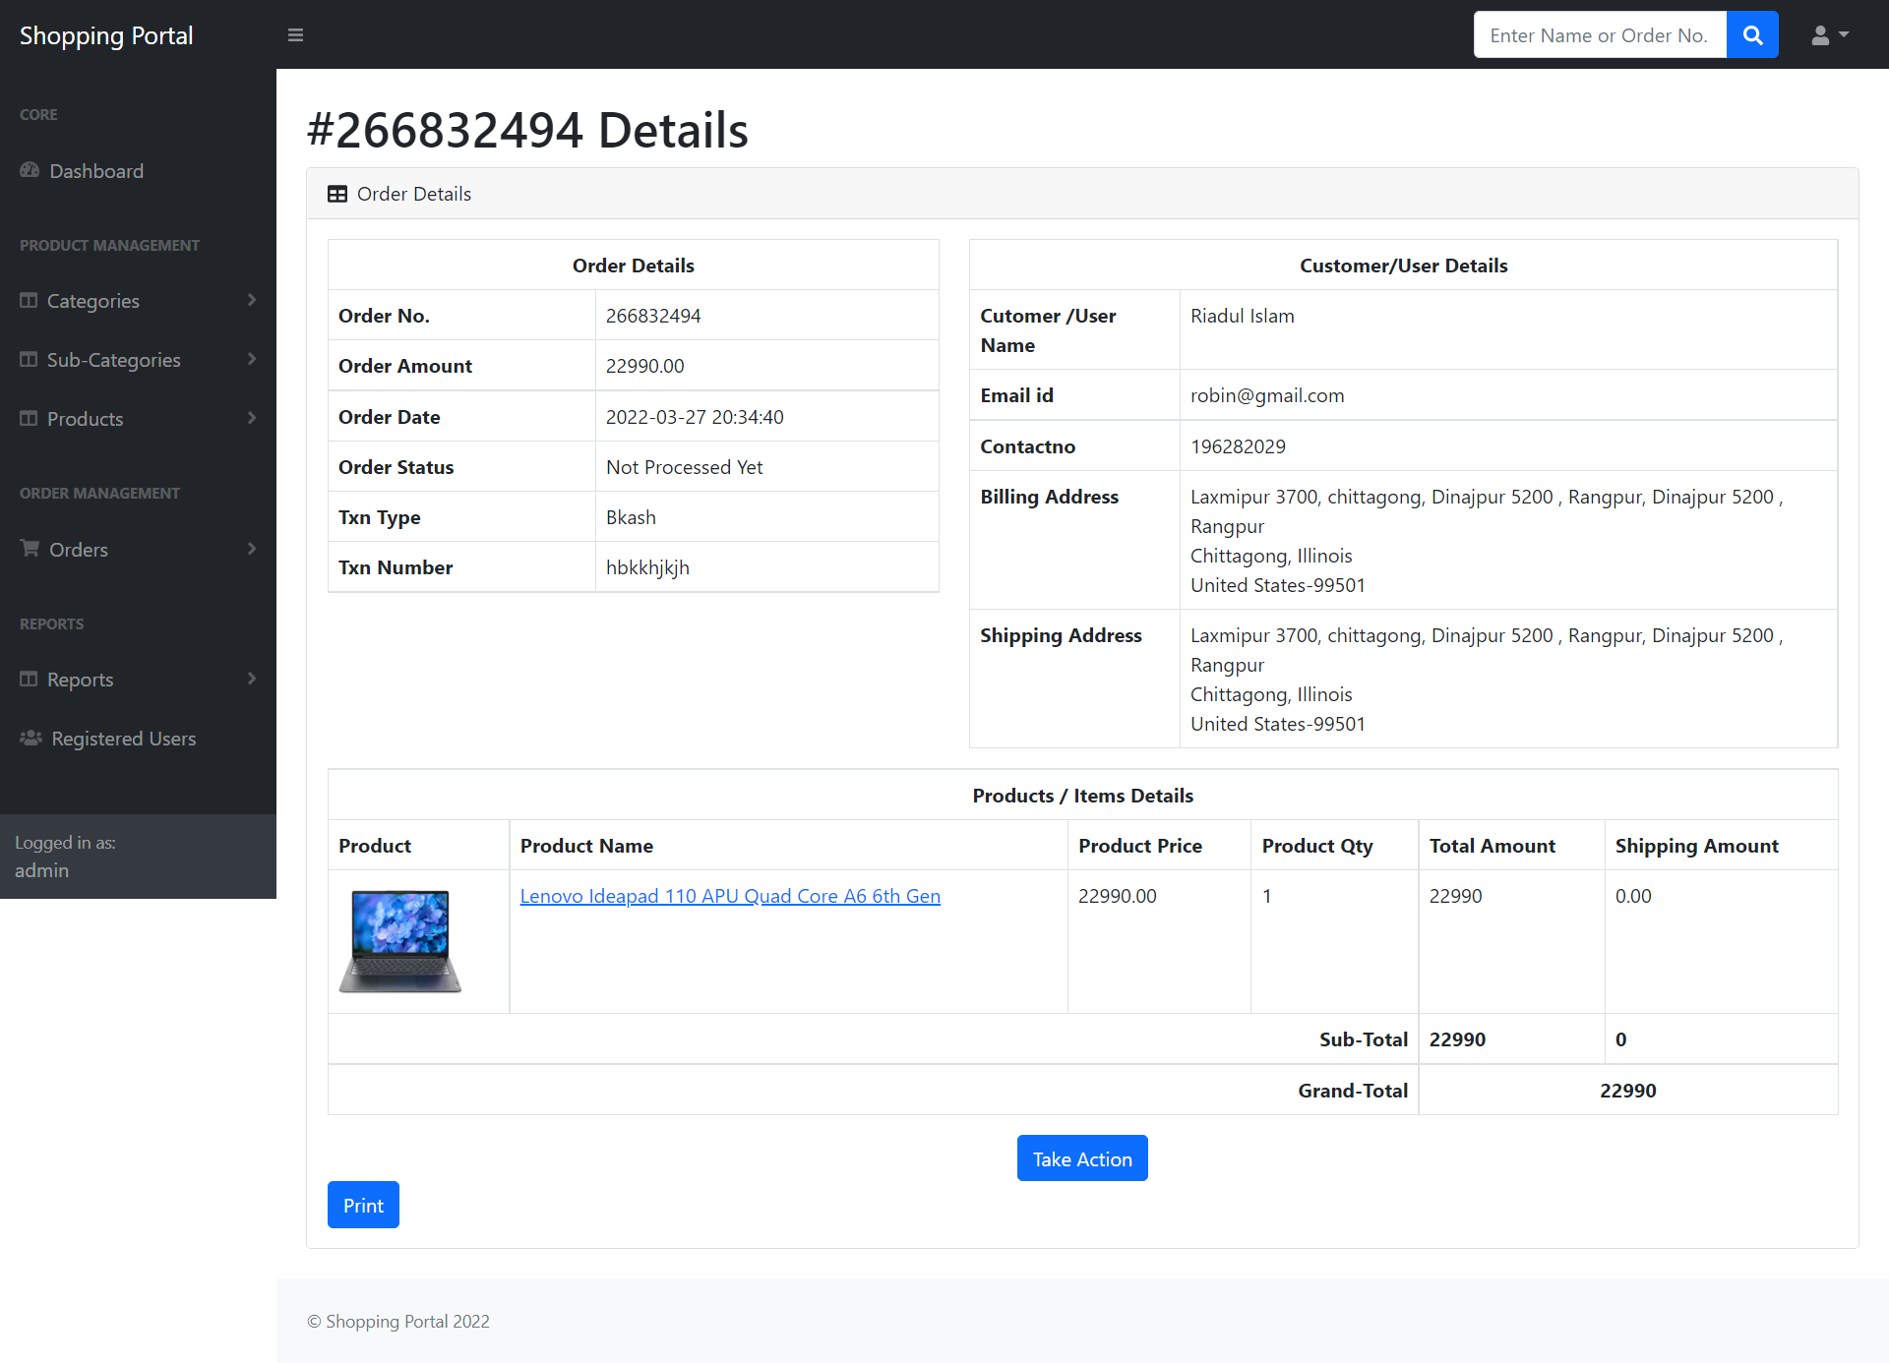

Order manager

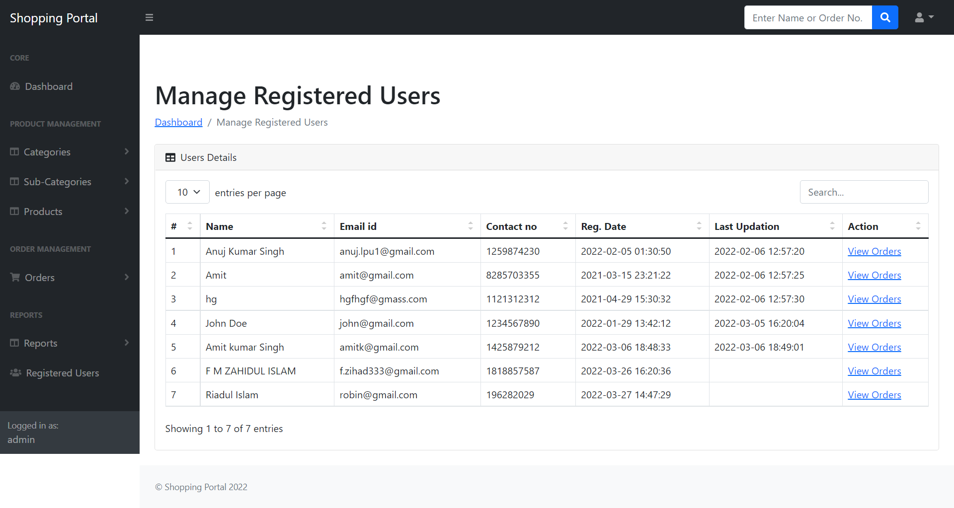

USer manager

### Chapter 7

## Conclusion and Future work

We are now at the end of our applied thesis report. We will talk about the summary and future enhancements that could be done.

### 7.1. Conclusion

E-commerce is fast gaining ground as an accepted and used business paradigm. More and more business houses are implementing websites providing functionality for performing commercial transactions over the web. It is reasonable to say that the process of shopping on the web is becoming commonplace. Association of Bangladesh (e-Cab), the trade body for eCommerce in Bangladesh, estimates there are 700 eCommerce sites We think Bangladesh needs more sustainable e-commerce to cop with the new era of business technology

The objective of this project was to develop a general-purpose e-commerce store where any product (such as books, CDs, computers, mobile phones, electronic items, and home appliances) can be bought from the comfort of home through the Internet.

The Project was designed and developed in such a way that future modifications can be done easily. The following conclusions can be deduced from the development of the project.

* Automation of the entire system improves efficiency
* It provides a friendly graphical user interface which proves to be better when compared to the existing system.
* It gives appropriate access to the authorized users depending on their permissions.
* It effectively overcomes the delay in communications.
* Updating of information becomes so easier.
* System security, data security and reliability are the striking features.
* The System has adequate scope for modification in future if it is necessary.

### 7.2. Future Enhancement

This application avoids manual work and the problems concerned with it. It is an easy way to obtain information regarding the various products information that is present in the Supermarkets.

Well, We have worked hard in order to present an improved website better than the existing ones regarding the information about the various activities. Still, we found out that the project can be done in a better way. Primarily, when we request information about a particular product it just shows the company, product id, product name, and no. of quantities available. So, after getting the information we can get access to the product company website just by a click on the product name.

### Chapter 8

## Reference and Bibliography

## Bibliography

* “HTML and CSS: Design and Build Websites” 1st Edition

by Jon Duckett

* “Database System Concepts” Seventh Edition

by Avi Silberschatz, Henry F. Korth, S. Sudarshan. ISBN 9780078022159

* “PHP and MySQL Web Development ” 5th Edition

by Luke Welling, Laura Thomson

* “Murach's PHP and MySQL” (3rd Edition)

by Joel Murach (Author), Ray Harris (Author), Anne Boehm (Editor)

* “PHP & MySQL: Server-side Web Development” 1st Edition

by Jon Duckett

* “Ecommerce Evolved: The Essential Playbook” 1st Edition

by Tanner Larsson

* “Head First PHP & MySQL”

Book by Lynn Beighley and Michael Morrison

* “PHP & MySQL for Dummies”

Book by Janet Valade

## Websites

* www.google.com
* www.w3schools.com
* www.tutorialspoint.php
* http://stackoverflow.com

## Reference

* HTML5 Introduction, w3schools. Section: “What is HTML5?” Accessed on 22 march

2022. [Http://www.w3schools.com/html/html5_intro.asp](http://www.w3schools.com/html/html5_intro.asp).

* JavaScript Overview, Mozilla Developer Network. Section: “What is JavaScript?”

Last update on 23 October 2012. Accessed on 22 march 2022.

* Https://developer.mozilla.org/en-US/docs/JavaScript/Guide/JavaScript_Overview.
* AJAX Introduction, w3schools. Sections: “What is AJAX?”, “How AJAX Works”

and “AJAX is Based on Internet Standards”. Accessed on 22 march 2022.

[Http://www.w3schools.com/ajax/ajax_intro.asp](http://www.w3schools.com/ajax/ajax_intro.asp).

* Title page, official website of jQuery. Section: “What is jQuery?” Accessed on 22

march 2022. [Http://jquery.com](http://jquery.com).

* jQuery Introduction, w3schools. Section: “What is jQuery?” Accessed on 22 march

2022. [Http://www.w3schools.com/jquery/jquery_intro.asp.](http://www.w3schools.com/jquery/jquery_intro.asp.)

* CSS Introduction, w3schools. Sections: “What is CSS” and “Styles Solved a Big

Problem”. Accessed on 22 march 2022. [Http://www.w3schools.com/css/css_intro.asp.](http://www.w3schools.com/css/css_intro.asp.)

* CSS3 Introduction, w3schools. Whole article. Accessed on 22 march 2022.

[Http://www.w3schools.com/css3/css3_intro.asp.](http://www.w3schools.com/css3/css3_intro.asp.)

* Media Queries, Webflux. Accessed on 22 march 2022.

[Http://www.css3.info/preview/media-queries/.](http://www.css3.info/preview/media-queries/.)

* PHP Introduction, w3schools. Sections: “What is a PHP file?”, “What Can PHP Do?”

and “Why PHP?”. Accessed on 22 march 2022.

[Http://www.w3schools.com/php/php_intro.asp](http://www.w3schools.com/php/php_intro.asp).

* PHP Tutorial, learnphp-tutorial. Section: “How PHP Works”. Last update on 3 January 2022. Accessed on 22 march 2022-

[Http://www.keithjbrown.co.uk/vworks/php/php_p1.php](http://www.keithjbrown.co.uk/vworks/php/php_p1.php).

* Introduction to SQL, w3schools. Sections: “What can SQL do?” and “SQL is a Standard – BUT…”. Accessed on 23 march 2022.

[Http://www.w3schools.com/sql/sql_intro.asp](http://www.w3schools.com/sql/sql_intro.asp).

* What is MySQL, 2022. Blog about MySQL. Accessed on 23 march 2022.

[Http://www.howtomysql.net/what-is-mysql.html](http://www.howtomysql.net/what-is-mysql.html).

* Gopi, A. 2010. Database System Concepts – Part 1. Section: “Query processing”. Accessed on 23 march 2022. [Http://eccentricabhi.wordpress.com/2010/05/21/databasesystem-concepts-part-i/](http://eccentricabhi.wordpress.com/2010/05/21/databasesystem-concepts-part-i/).

### 